bs00554_

Computing

# 

Spellings

* Children will be given a spelling list every Friday to be tested at the end of the following week. Please help your child to learn these – a short time every day works best! The spellings will be in your child’s homework book and will updated weekly. You will find these spellings need to be put into a sentence as part of the homework, this is to ensure children understand the words in context.

## Reading

* It is important to read at home every day. Please encourage your child to read a range of varied texts which should include their class reading book. Children will be given a reward of extra break time if their reading record in signed by a parent/guardian each day of the week showing they have read. If you listen to your child read at night, please feel free to sign a comment in their Reading record.

English focusses this half term

This half term in English we will be reading Cosmic by Frank Cottrell-Boyce. The author of the book is local to St Helens, being from Rainhill. The book follows the adventures of a boy who is a little older than he looks, so much so that he manages to trick his way into space! The children will explore story writing, letters, diary entries, summaries and non-chronological reports.

Year 5 English

This year, the school will be following a new computing scheme called TeachComputing. During the first half of the Autumn term, the class will be looking at systems. Learners develop their understanding of computer systems and how information is transferred between systems and devices. They explain the input, output, and process aspects of a variety of different real-world systems. The class will also look at how search engines work and what influences results.

Topic

**DT**

This half term, Year 5 will be looking at building a rocket capable of taking passengers to space. This topic is linked with our English book (Cosmic) as well as our Science unit of Earth and Space! The class will be experimenting with different materials and contraptions in order to make their rocket move.

**RE**

During this half term, we will be looking at Christianity and what makes people do the wrong thing. This focuses on a variety of stories from the Bible, looking into detail about how temptation influenced their choices.

Maths

* Make sure your child knows their times tables –

2s, 3s, 4s 5s and 10s first, then extended to 12x12. This instant recall is essential in Year 5. We will be starting times table recap sessions during schooltime on a Wednesday to aid the learning of these.

Autumn 1 - During the first half term of Year 5, the children will be looking at progressing their skills in place value. This includes: understanding Roman Numerals, numbers up to a million, rounding numbers and comparing and ordering numbers. In the later part of the half term, the class will be looking at addition and subtraction including using mental strategies, adding and subtracting up to 4 digit numbers, multi-step problems and missing numbers.

Autumn 2 – To finish off the term on the lead up to the Christmas break, the class will be tackling multiplication and division. This includes looking at multiples, factors, prime numbers, square numbers as well as multiplying and dividing by 10, 100 and 1000. Following this, Year 5 will start to look at fractions. They will be adding and subtracting a variety of fractions, converting both mixed numbers and improper fractions, ordering fractions and comparing them.

This half term Year 5 will be looking at Earth and Space. The topic aims to look at explaining how our Solar System works. The children will explore all the planets in the Solar System, how they move, the movement of the Sun as well as the different shapes of the moon.

**Science**

**EEkGeography week**

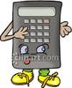

History

This half term the children will be looking at the Vikings. We will look at who the Vikings were, sequencing a timeline of historic events featuring the Vikings’ time in England, Anglo-Saxon Kings, Danelaw and how one great battle changed the Vikings’ history.

**Homework**

Your child will receive Maths and English homework each week. This will be handed out each Friday and is expected to be handed in by the following Friday. Children will also receive spellings to learn on a Friday (stuck into homework books), which will be tested on a Friday afternoon.

Please encourage your child to read for 10/15 minutes each night and ensure reading records are in daily.

Homework is expected to be in the same standard of presentation as in class, with it being in the homework book

and completed in blue pen or pencil.

Attendance in school is exceptionally important for every child to progress and learn. Our target this year is 96%. Did you know that even though 95% sounds good, it equates to one day off a month? The curriculum in Year 5 progresses rapidly and if your child misses out they are already ‘on the back foot’ when they return to school.  If your child feels slightly unwell but you think that they would be OK eg they are developing a cold, headache tummy bug, try to encourage them to attend. If your child does become more unwell we will contact you. Often children feel better after that initial ‘wake up’ feeling. Education is free, fun and rewarding- enjoy every day!

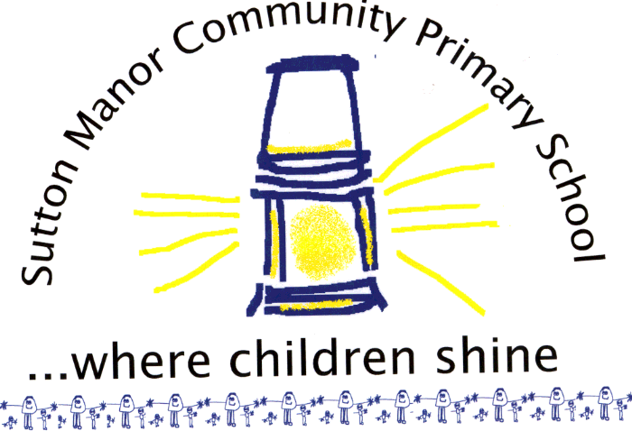

**E- Safety**

The internet is amazing! Children can play, learn, create and connect - opening up a whole world of exciting possibilities. As we all appreciate, ensuring the safety of our children is a pivotal role as a parent, carer and teacher. In the digital era, we need to consider how to support them in making good choices about staying safe. The NSPCC have these 4 key tips to help, whether you’re an online expert or you’re not sure where to start:

Explore the online world together

2.       Talk to your child about staying safe online

3.       Manage the software and tools your family use

4.       Agree rules about what’s ok and what’s not

Useful links:

www.nspcc.org.uk/OnlineSafety

www.thinkuknow.co.uka

**Helping Your Child at Home**

**A Guide for Parents**

**Year 5**