We will be doing a set of spellings every week. Sent
Year 6 English

Spellings

Reading
- The books we are reading in class are Ratburger by David Walliams, The Promise, The Man Who Walked Between The Towers and Clockwork by Philip Pullman.
- Children will be allowed to take a book from class to be returned when completed and placed in the Reading Book box. The children will then do a book review.
- It is important to read at home every day.

Writing and Grammar
- Year 6 will be writing about The Promise and The Man Between The Towers this term. We will be improving our writing by learning how to include different sentence types in class and grammatical features . You can help your child with this by asking them to show you a sentence type we use and to write another example in their homework books.

Geography
The focus on Geography this year will be orienteering using the school environment.

Science…This term we are looking at light and dark. We will be investigating and carrying out experiments how light travels, how it is reflected in to the eye and why shadows are formed.

History…We are looking at the Industrial Revolution 1760 – 1900
This also links to our Art and the artist LS Lowry.

RE…We are learning about Christianity and asking
the question ‘Is life like a journey?’
home Tuesday and tested on Friday.

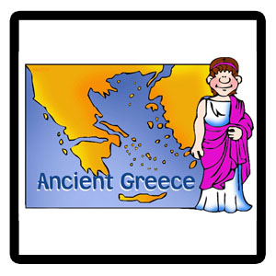

International Week

On the 21st September we will be doing various activities linked to ‘International Week’

By Year 6, your child should know their times tables up to 12x12, as well as the related division facts. If your child still needs to practice their tables, quick tests at home as well as spending time playing against other children on websites such as www.tutpup.com will help them.

the Olympic games

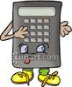
Maths
Homework
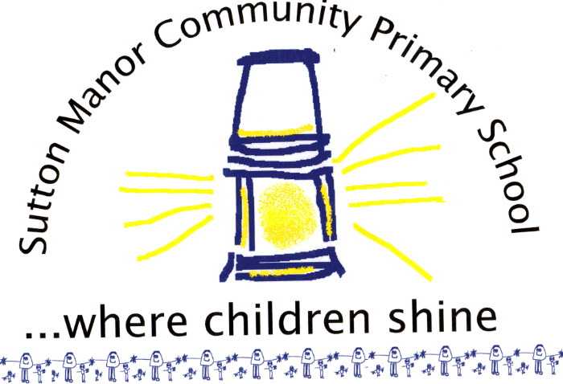
In addition to reading, your child will usually receive a piece of Maths and English homework each week, unless given a project.
They will also have weekly spellings that will be tested each Friday and new spellings will be sent out on Tuesday. These can be found on the class page on the website if they are lost. Homework is expected to be in the same standard of presentation as in class, with it being in the homework book and completed in blue pen.
Homework will be sent out a Tuesday and returned Friday. The children will mark their own work using a green pen (on a Friday) with the class teacher.
Uniform Policy
As of Monday 14th September we are amending our uniform policy to allow children with pierced ears to wear one set of simple stud earrings if they so wish. We would still strongly recommend that children remove their earrings before coming to school, however if they are unable to do so you must sign a disclaimer.

By signing a disclaimer you are taking full responsibility for your child’s earrings and all health and safety risks associated with wearing them to school, which includes playtimes and PE lessons. Children may tape the back of their earrings for PE lessons to lessen the risk of injury, but school and staff cannot do this for them.
Please note that this disclaimer does not apply to swimming.
This amendment ONLY applies to earrings, other jewellery will not be permitted, including any additional piercings.

Helping Your Child at Home
A Guide for Parents

Year 6

