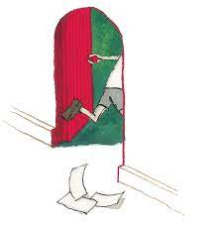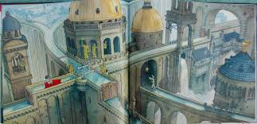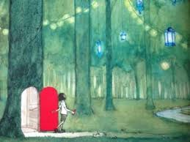

**Grammar**

* **Use a dictionary to find out synonyms.**
* **Descriptive sentences including prepositions and expanded noun phrases.**
* **Use a variety of punctuation within writing (full stops, commas, inverted commas, exclamation marks).**
* **Use pronouns appropriately.**
* **Use present perfect.**

**Reading**

* **Be able to use inference skills when exploring pictures in the book.**
* **Discrete reading lessons focusing on inference skills.**

**Writing**

* **Write a prediction based on the front cover and blurb (to discuss)**
* **Write a letter (to entertain)**
* **Be able to create our own journey based on the pictures in the book (to entertain)**

**Cover**

