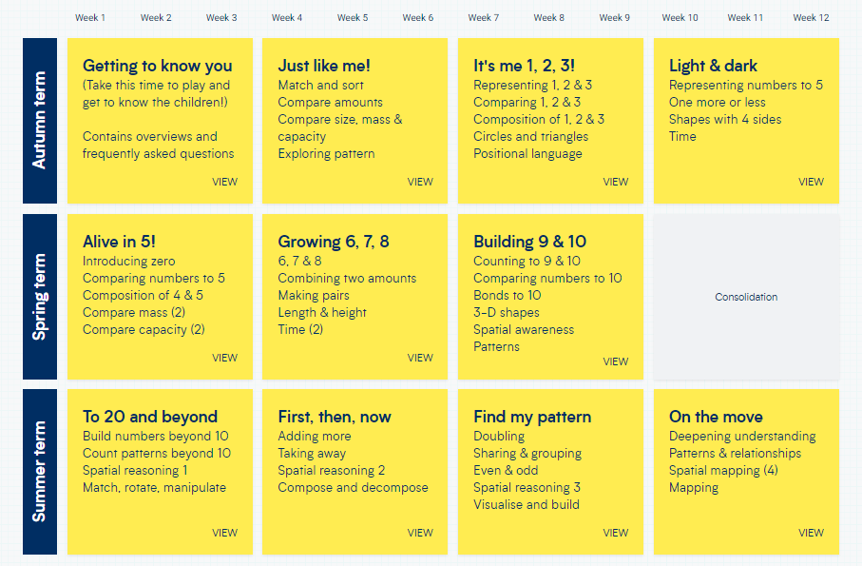

**White Rose Maths - EYFS**

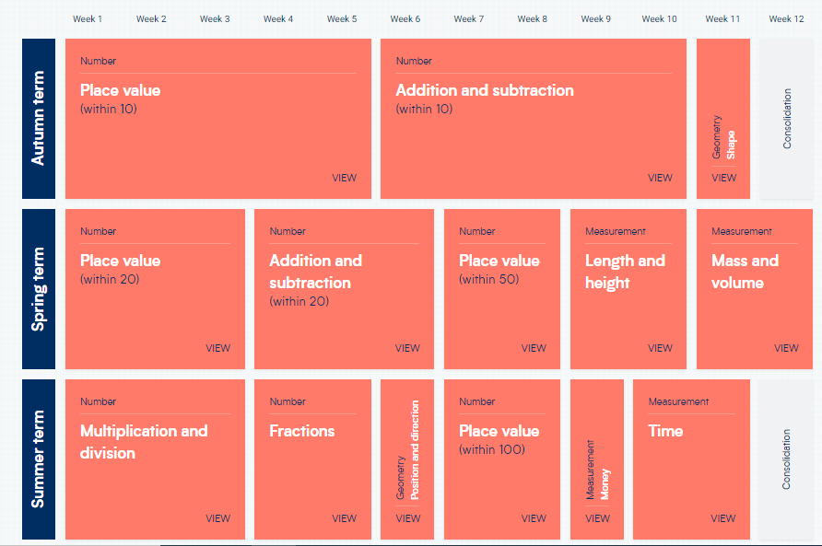

**White Rose Maths – Year 1**

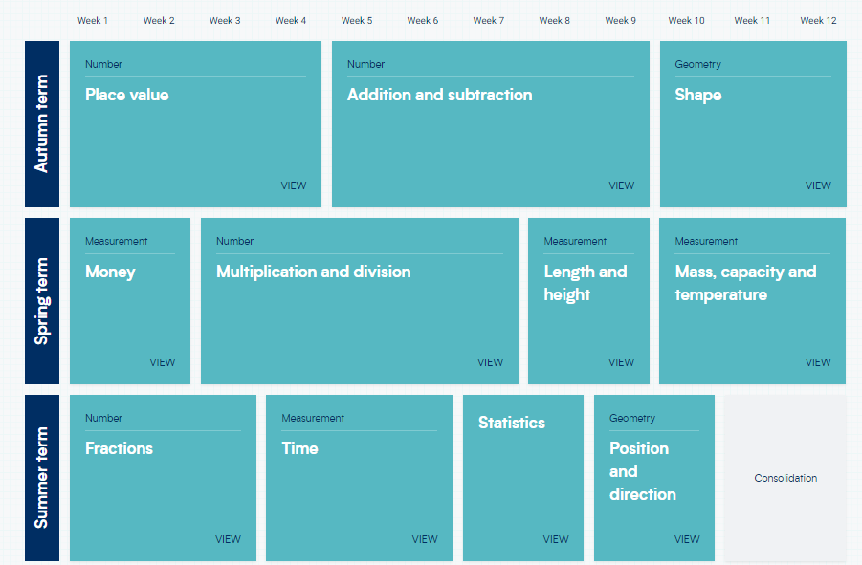

**White Rose Maths – Year 2**

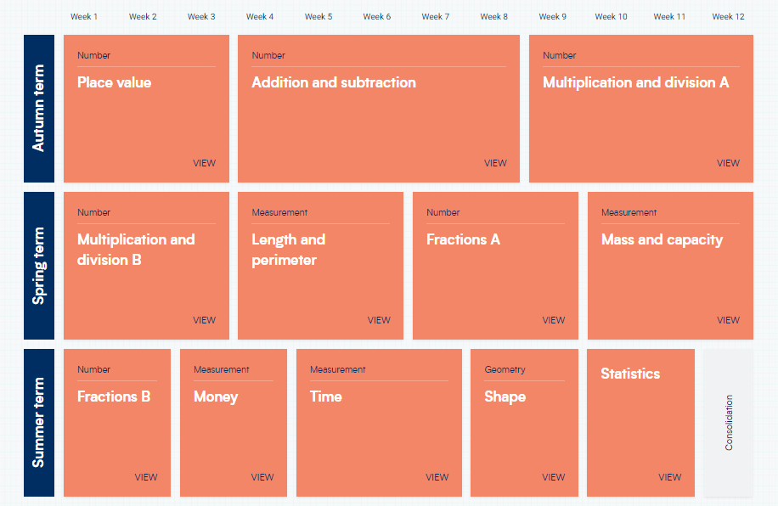

**White Rose Maths – Year 3**

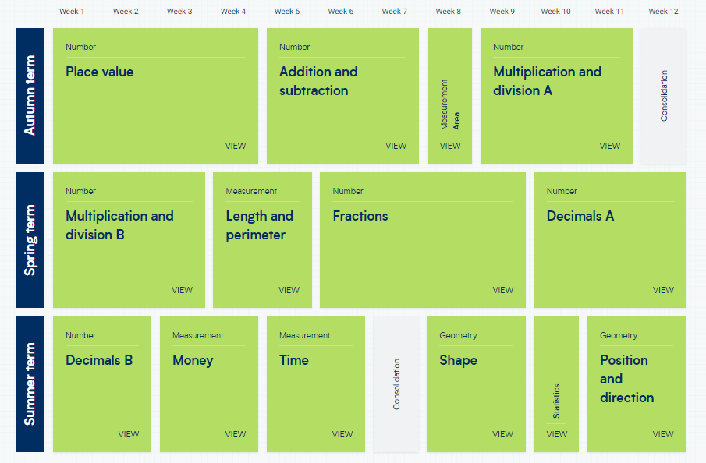

**White Rose Maths – Year 4**

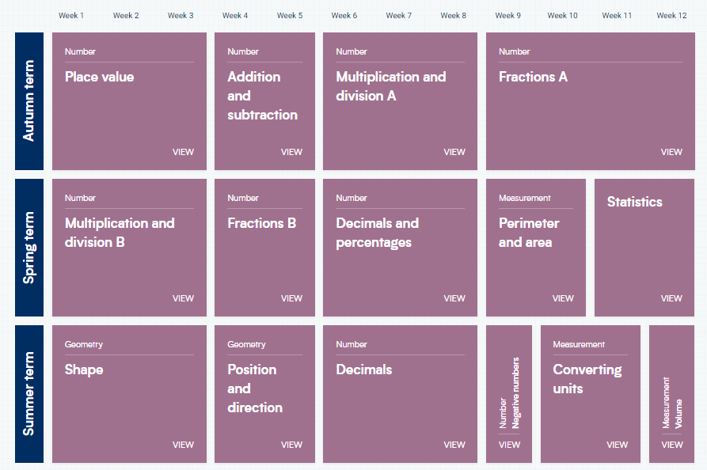

**White Rose Maths – Year 5**

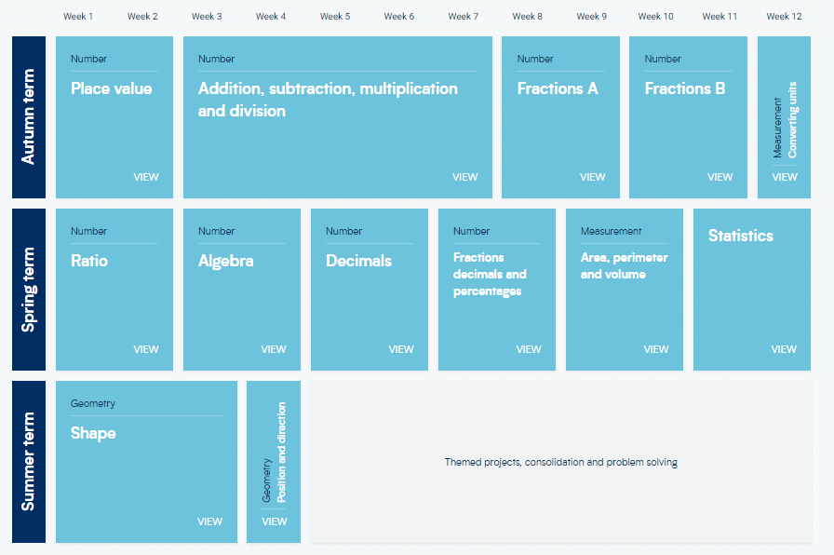

**White Rose Maths – Year 6**