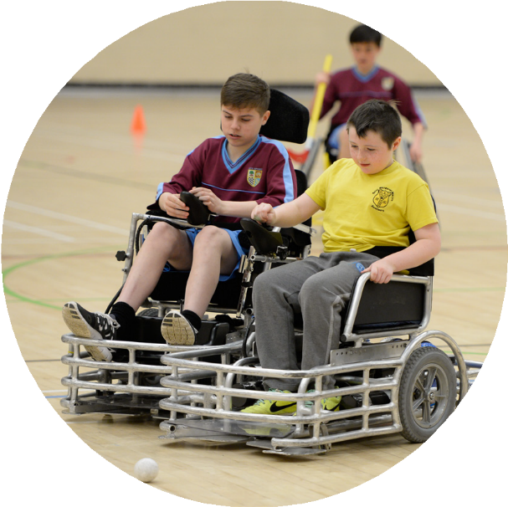
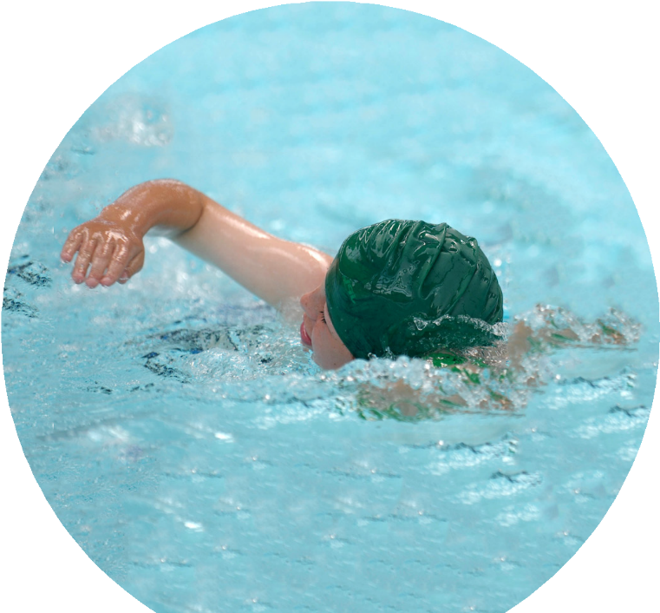
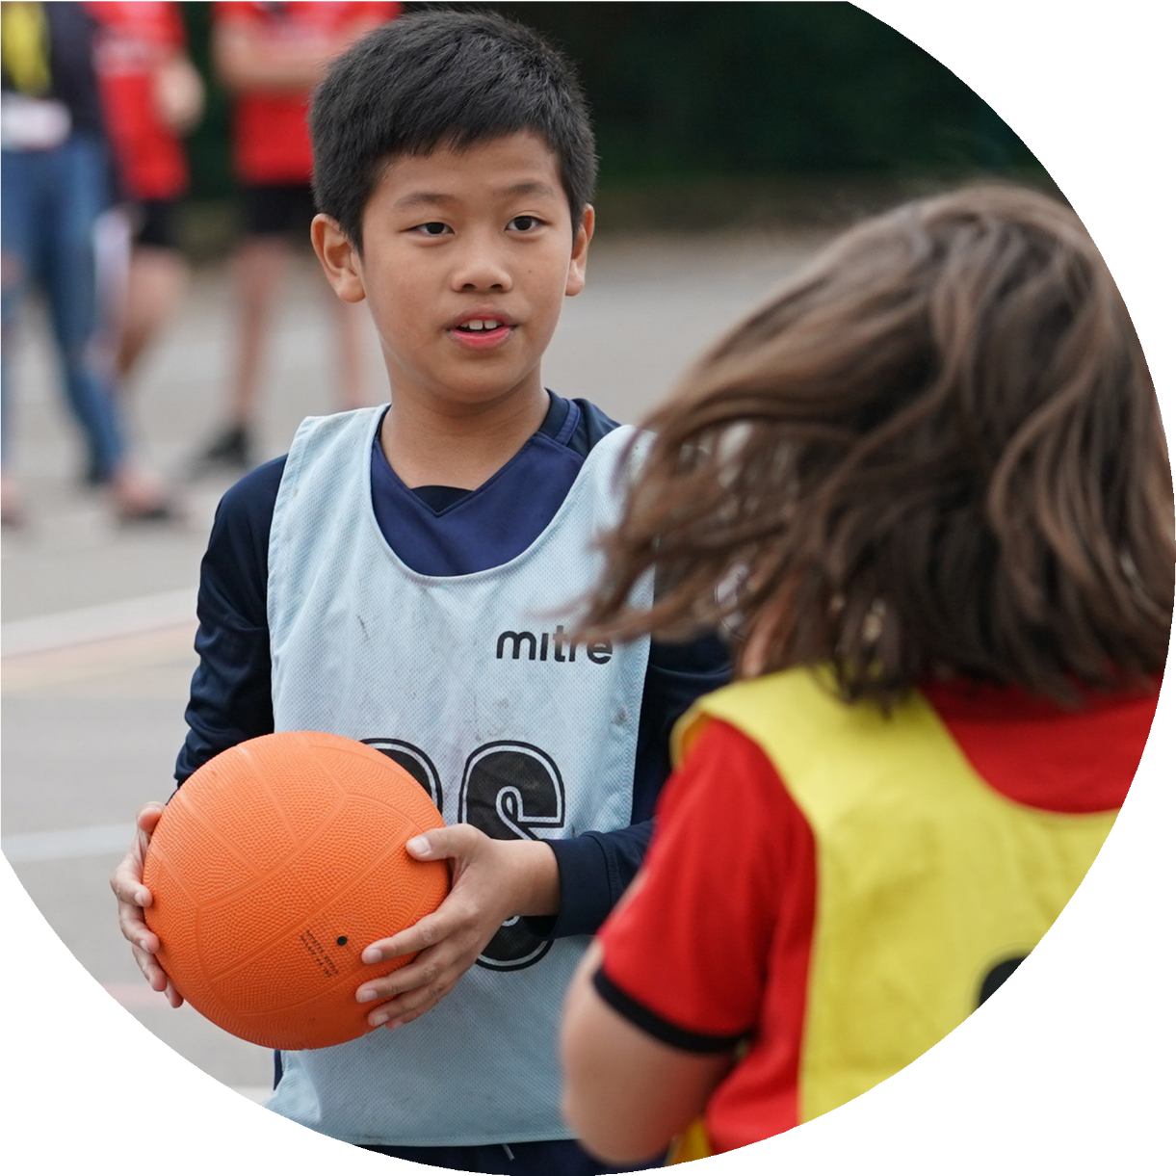

Evidencing the impact of the Primary PE and sport premium
Website Reporting Tool Revised July 2021

Commissioned by

Created by

It is important that your grant is used effectively and based on school need. The Education Inspection Framework makes clear there will be a focus on ‘whether leaders and those responsible for governors all understand their respective roles and perform these in a way that enhances the effectiveness of the school’.

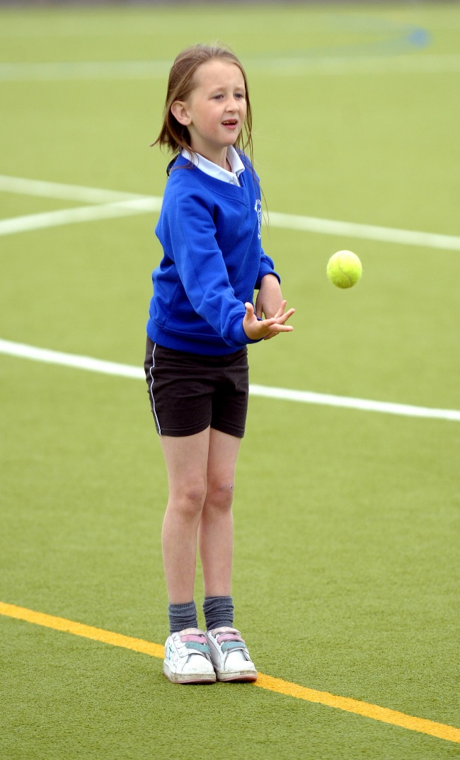
Under the Quality of Education Ofsted inspectors consider:
Intent - Curriculum design, coverage and appropriateness
Implementation - Curriculum delivery, Teaching (pedagogy) and Assessment
Impact - Attainment and progress

To assist schools with common transferable language this template has been developed to utilise the same three headings which should make your plans easily transferable between working documents.

Schools must use the funding to make additional and sustainable improvements to the quality of Physical Education, School Sport and Physical Activity (PESSPA) they offer. This means that you should use the Primary PE and sport premium to:

- Develop or add to the PESSPA activities that your school already offer
- Build capacity and capability within the school to ensure that improvements made now will benefit pupils joining the school in future years
- The Primary PE and sport premium should not be used to fund capital spend projects; the school’s budget should fund these.

Pleasevisitgov.ukfortherevisedDfEguidanceincludingthe5keyindicatorsacrosswhichschoolsshoulddemonstrate animprovement.Thisdocumentwillhelpyoutoreviewyourprovisionandtoreportyourspend.DfEencouragesschools to use this template as an effective way of meeting the reporting requirements of the Primary PE and sport premium.

We recommend you start by reflecting on the impact of current provision and reviewing the previous spend.

Schools are required to publish details of how they spend this funding, including any under-spend from 2019/2020, as well as on the impact it has on pupils’ PE and sport participation and attainment. All funding must be spent by 31st July 2022.

We recommend regularly updating the table and publishing it on your website throughout the year. This evidences your ongoing self-evaluation of how you are using the funding to secure maximum, sustainable impact. Final copy must be posted on your website by the end of the academic year and no later than the 31st July 2021. To see an example of how to complete the table please click HERE.
Created by: Supported by:

Details with regard to funding
Please complete the table below.

Total amount carried over from 2019/20 | £0
Total amount allocated for 2020/21 | £17640
How much (if any) do you intend to carry over from this total fund into 2021/22? | £ 3000
Total amount allocated for 2021/22 | £ 17800
Total amount of funding for 2021/22. To be spent and reported on by 31st July 2022. | £ 20800
Swimming Data
Please report on your Swimming Data below.

Meeting national curriculum requirements for swimming and water safety.  N.B. Complete this section to your best ability. For example you might have practised safe self-rescue techniques on dry land which you can then transfer to the pool when school swimming restarts.  Due to exceptional circumstances priority should be given to ensuring that pupils can perform safe self- rescue even if they do not fully meet the first two requirements of the NC programme of study | Due to Covid, no swimming in water was completed. There were additional difficulties with the allocation of swimming facilities across the borough, school explored alternative options, but could not source a pool resource. The data below shows the % of the Year 6 cohort when they last accessed swimming.
What percentage of your current Year 6 cohort swim competently, confidently and proficiently over a distance of at least 25 metres?  N.B. Even though your pupils may swim in another year please report on their attainment on leaving primary school at the end of the summer term 2020.  Please see note above | 38%
What percentage of your current Year 6 cohort use a range of strokes effectively [for example, front crawl, backstroke and breaststroke]?  Please see note above | 40%
What percentage of your current Year 6 cohort perform safe self-rescue in different water-based situations? | 37%
Schools can choose to use the Primary PE and sport premium to provide additional provision for swimming but this must be for activity over and above the national curriculum requirements. Have you used it in this way? | Yes

Action Plan and Budget Tracking
Capture your intended annual spend against the 5 key indicators. Clarify the success criteria and evidence of impact that you intend to measure to evaluate for pupils today and for the future.

Academic Year: 2021/22 | Total fund allocated: £20,800 | Date Updated: July 2022
Key indicator 1: The engagement of all pupils in regular physical activity – Chief Medical Officers guidelines recommend that primary school pupils undertake at least 30 minutes of physical activity a day in school |  |  |  | Percentage of total allocation:
 |  |  |  | 78 %
Intent | Implementation |  | Impact
Your school focus should be clear | Make sure your actions to achieve | Funding | Evidence of impact: what do | Sustainability and suggested
what you want the pupils to know | are linked to your intentions: | allocated: | pupils now know and what | next steps:
and be able to do and about |  |  | can they now do? What has
what they need to learn and to |  |  | changed?:
consolidate through practice:
- All pupils receive 2 hours of quality PE lesson time every week. Ensure that adequate is equipment is available for every child to participate successfully.  - 2. All children to have the opportunity to attend extra-Curricular sports clubs throughout the year.  - Work with sports coach to deliver small sports competitions.  - Attend School Games and St Helens council sports competitions.  - Children to understand the 'Spirit of the games values' as part of School Games award  - Sports achievements to be celebrated around school and in assembly.  - To look towards the Gold School Games award.  - Target lowest 20% of children who take part in physical activity.  - Additional swimming opportunities from Year 2, extra half term for Year 6. | - Purchase of additional PE resources to support PE sessions e.g. Balls/Racquets.  - Timetabled extra-curricular sports clubs, before and after school organised on a staggered rota to ensure that all pupils have the opportunity to attend.  - P.E Lead will have meetings with Sports Leaders and children to discuss opportunities that the children would enjoy. A range of activities during P.E and extra-curricular activities will be offered. A range of competitions will be taken part in throughout the year. This will be within school and also outside of school. P.E Lead, staff and sports coach will use the School Games 'Spirit of the Games Values' to promote values. Children who show a lack of physical activity will also be targeted in games during playtime and encouraged to join extra curricular clubs. | £1000 for equipment  Sports Coach: £1,589 (saints)  £9,600 (AG)  Gymnastics coaching £1,050  Transport to tournaments- £2,922 (£60 per tournament)  Additional swimming: £2000  Additional transport costs  £1500 | Initial spend has ensured that all planned PE sessions have been fully resourced leading to greater participation and active minutes in lessons. Equipment audit by PE coordinator  Extra-curricular sports clubs are well attended.  A range of sports offered via PE, class competitions have taken place.  Class sports days took place.  Dance, multiskills, gymnastics, football, rugby took place throughout the academic year.  Active challenges were taken on during lockdown via Teams through live lessons, Joe Wickes PE.  WIDER IMPACT AS A RESULT OF ABOVE:  • Pupils are more active in PE lessons - take part without stopping to rest. When they returned from the first lockdown, they were physically more unfit and some children had gained weight. Fitness and resilience has improved.  • Standards achieved in PE NC are improving  • Attitudes to learning improved - better concentration in lessons, better behaviour on the playground, children are taking learning from lessons and clubs into their playtime games.  - Children have resumed swimming after two years, they are developing more confidence in the water and are learning to swim with and without aids. | Continued monitoring  of PE resources for wear and tear.  Purchasing plan to ensure all sports are adequately covered.  Continue with offering range of activities.  Introduce Sports Ambassadors meetings with new Ambassadors/play leaders  School Games competitions to start again after COVID.  Look at Gold award.  Continue to target lowest 20% and the most vulnerable, including those with SEND, with clubs, P.E and classes.  Staff to offer clubs and P.E sessions to pupils each week.  Promote and display school games values.
Key indicator 2: The profile of PESSPA being raised across the school as a tool for whole school improvement |  |  |  | Percentage of total allocation:
 |  |  |  | % AS above
Intent | Implementation |  | Impact
Your school focus should be clear | Make sure your actions to achieve | Funding | Evidence of impact: what do | Sustainability and suggested
what you want the pupils to know | are linked to your intentions: | allocated: | pupils now know and what | next steps:
and be able to do and about |  |  | can they now do? What has
what they need to learn and to |  |  | changed?:
consolidate through practice:
- Survey children on sports provision and collect pupil voice.  - Offer a range of sports and activities during P.E time throughout the year.  - Offer a range of extra-curricular activities.  - Work with sports coach to deliver small sports competitions.  - Target lowest 20% of children who take part in physical activity. | Class teachers will capture pupil voice, evidence within class PE books.  PE lead to monitor and meet with children to discuss sports provision.  Class teachers to survey class on sports provision.  A range of activities during P.E and extra-curricular activities will be offered. A range of competitions will be taken part in throughout the year. This will be within school and also outside of school. P.E Lead, staff and sports coach will use the School Games 'Spirit of the Games Values' to promote values. Children who show a lack of physical activity will also be targeted in games during playtime and encouraged to join extra curricular clubs. | Costings for clubs, coaches, gymnastics, Saints as above | Extra-Curricular activities not as often due to COVID.  Class competitions taken place via P.E.  Class Sports days taken place | Sports ambassadors/play leaders to meet regularly with PE lead to discuss what opportunities the children would enjoy.
Key indicator 3: Increased confidence, knowledge and skills of all staff in teaching PE and sport |  |  |  | Percentage of total allocation:
 |  |  |  | 4%
Intent | Implementation |  | Impact
Your school focus should be clear | Make sure your actions to | Funding | Evidence of impact: what do | Sustainability and suggested
what you want the pupils to know | achieve are linked to your | allocated: | pupils now know and what | next steps:
and be able to do and about | intentions: |  | can they now do? What has
what they need to learn and to |  |  | changed?:
consolidate through practice:
Build capacity and capability within the school to ensure that improvements made now will benefit pupils joining the school in future years. | Sports Coach to work alongside class teachers and support staff to ensure high standard of on-going CPD.  P.E Lead will find out areas of P.E that staff may want to improve.  P.E lead will find a range of relevant CPD and offer this to relevant staff. P.E lead will discuss progression document with staff and make sure it is up to date for staff to use. | £300 for orienteering  Supply cover for PE lead to attend CPD  £500 | Structure to the PE lessons has improved Teacher’s working knowledge is more secure. There is now improved progression in the teaching and learning of PE across the curriculum.  Orienteering CPD took place.  Statement of intent, progression document and timetable renewed/updated by P.E Lead. | Monitor quality of Teacher-led PE lessons to ensure positive impact of CPD.  Staff to use progression document in PE lessons next academic year.  Staff to incorporate orienteering physical activities into wider curriculum such as P.E., geography and maths
Key indicator 4: Broader experience of a range of sports and activities offered to all pupils |  |  |  | Percentage of total allocation:
 |  |  |  | 30%
Intent | Implementation |  | Impact
Your school focus should be clear | Make sure your actions to | Funding | Evidence of impact: what do | Sustainability and suggested
what you want the pupils to know | achieve are linked to your | allocated: | pupils now know and what | next steps:
and be able to do and about | intentions: |  | can they now do? What has
what they need to learn and to |  |  | changed?:
consolidate through practice:
Additional achievements:  1. To provide more opportunities for pupils to take part in physical activity during lunchtime and/or after school.  2. P.E Lead and Sports Coach to ensure all inclusive sports are offered during P.E and for extra-curricular.  3. Equipment is available for everybody to access all sports and physical activity. 4. To ensure School Games all inclusive competitions.  5. To ensure members of staff are available for extra support during P.E lessons.  6. To provide Forest school opportunities for the most vulnerable.  Quidditch tournament through Enrich Education | A specialist sports coaches helps deliver enriched sporting opportunities and to support specific curriculum areas e.g. gymnastics  Forest school leader non contact time.  Experience an alternative sporting competition | Costings for clubs, coaches, gymnastics, Saints and transport as above  £500 for Forest School  £495 | After school clubs that have been provided :  Wholes school sports events  A group of children have received Dance training from students at The Sutton Academy.  Beth Tweddle ,gymnastics for KS1 and KS2  Cheerleading through Saints  Rugby training  Football for KS1 and KS2  Children have had the opportunity Sky Try Rugby through Saints  Forest School was not offered to wider groups of vulnerable children due to the restrictions associated with children in bubbles. As a result, we targeted Early years and Year 6 as part of our vision that every child will have a forest school opportunity before they leave Sutton Manor. | Continue with a rolling programme of sporting activities to ensure that all pupils have the opportunity to attend extra -curricular events.  Re- establish Forest schools for the lowest 20% of less physical children, SEND and the most vulnerable.  Training for additional trained staff to ensure sustainability.

Key indicator 5: Increased participation in competitive sport |  |  |  | Percentage of total allocation:
 |  |  |  | 25%
Intent | Implementation |  | Impact
Your school focus should be clear | Make sure your actions to | Funding | Evidence of impact: what do | Sustainability and suggested
what you want the pupils to know | achieve are linked to your | allocated: | pupils now know and what | next steps:
and be able to do and about | intentions: |  | can they now do? What has
what they need to learn and to |  |  | changed?:
consolidate through practice:
To sustain School Games Awards Silver, working towards Gold.  To participate in more school sports  tournaments  To inspire more children to take up physical activity, regardless of ability  Membership of St Helens Association of Physical Education- | School to take part in a variety of competitive sports within St Helens, in accordance with the School Games Award.  PE lessons will include elements of competition and children will learn sportsmanship of winning and losing.  Extra-Curricular sports clubs will prepare the children for upcoming competitions. | Cost of coaching as key indicator 1.  Transport £ 2922  membership SLA £990 | Tournaments participated in 2019 and 2020 year:  Handball,  Rounders  Football, girls and boys  Rugby  Netball  Dodgeball  EYFS football  Whittle Cup  Sutton Shield  Swimming gala  Cricket  Indoor athletics  Some tournaments were cancelled as a result of Covid after Autumn term until Summer.  Funding has paid for the coaches, new equipment, team kit and travel to and from sports tournaments. | A full range of sports activities and tournaments to be mapped for participation.  Sign up to Saints Community Development sports offer.  Participate in tournaments and enrichment events  Book Beth Tweddle gymnastics  Widen sports coach offer to ‘Tinies’ two year olds, Nursery and Reception.

Signed off by
Head Teacher: | M Gladman
Date: | 22nd July 2021
Subject Leader: | H Lewis
Date: | 22nd July 2021
Governor:
Date:

