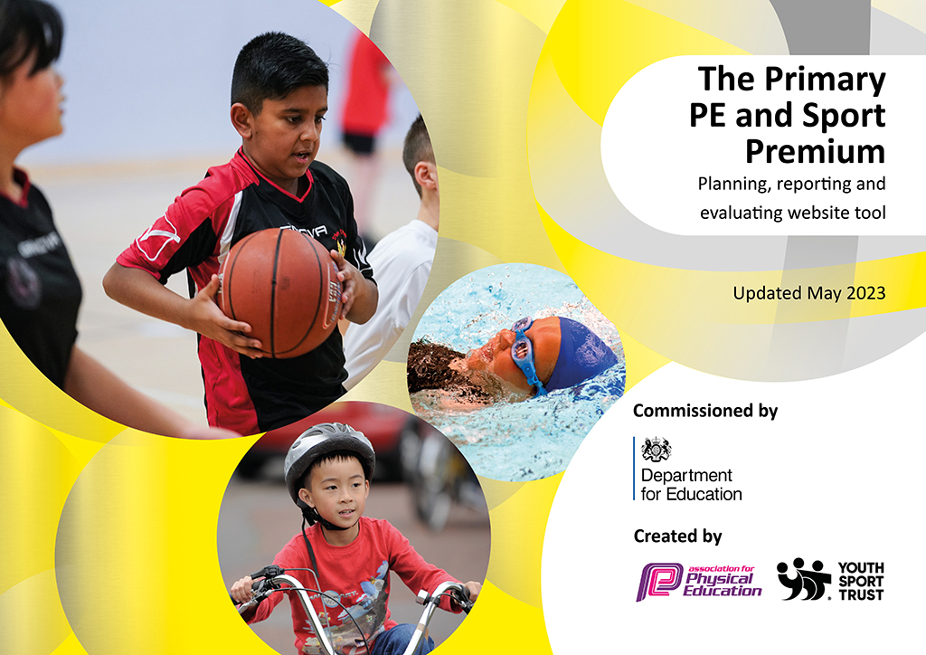
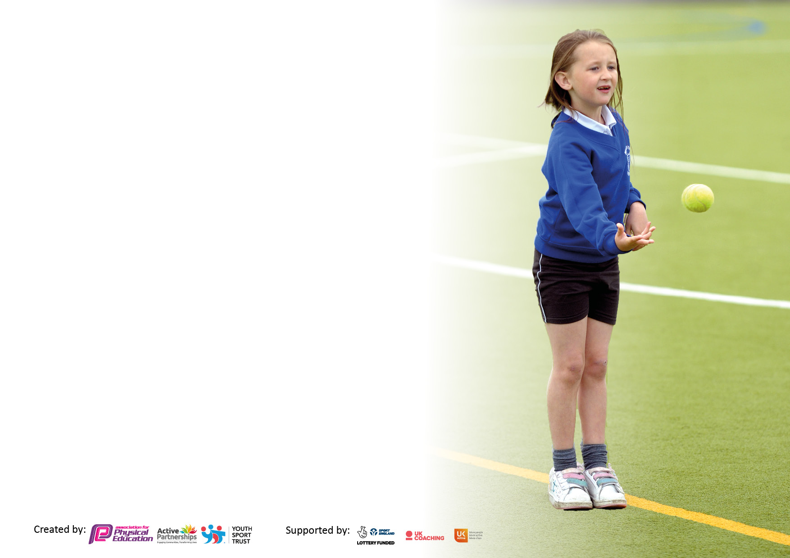

It is important that your grant is used effectively and based on school need. The Education Inspection Framework makes clear there will be a focus on ‘whether leaders and those responsible for governors all understand their respective roles and perform these in a way that enhances the effectiveness of the school’.

Under the Quality of Education Ofsted inspectors consider:
Intent - Curriculum design, coverage and appropriateness
Implementation - Curriculum delivery, Teaching (pedagogy) and Assessment
Impact - Attainment and progress

To assist schools with common transferable language this template has been developed to utilise the same three headings which should make your plans easily transferable between working documents.

Schools must use the funding to make additional and sustainable improvements to the quality of Physical Education, School Sport and Physical Activity (PESSPA) they offer. This means that you should use the Primary PE and sport premium to:

- Develop or add to the PESSPA activities that your school already offer
- Build capacity and capability within the school to ensure that improvements made now will benefit pupils joining the school in future years
- The Primary PE and sport premium should not be used to fund capital spend projects; the school’s budget should fund these.

Pleasevisitgov.ukfortherevisedDfEguidanceincludingthe5keyindicatorsacrosswhichschoolsshoulddemonstrate animprovement.Thisdocumentwillhelpyoutoreviewyourprovisionandtoreportyourspend.DfEencouragesschools to use this template as an effective way of meeting the reporting requirements of the Primary PE and Sport Premium.

We recommend you start by reflecting on the impact of current provision and reviewing the previous spend.

Schools are required to publish details of how they spend this funding, including any under-spend from 2021/2022, as well as on the impact it has on pupils’ PE and sport participation and attainment. All funding must be spent by 31st July 2023.

We recommend regularly updating the table and publishing it on your website throughout the year. This evidences your ongoing self-evaluation of how you are using the funding to secure maximum, sustainable impact. Final copy must be posted on your website by the end of the academic year and no later than the 31st July 2023. To see an example of how to complete the table please click HERE.

Details with regard to funding
Please complete the table below.

Total amount carried over from 2021/22 | £ 0
Total amount allocated for 2021/22 | £20800
How much (if any) do you intend to carry over from this total fund into 2022/23? | £0
Total amount allocated for 2022/23 | £17,719
Total amount of funding for 2023/23. To be spent and reported on by 31st July 2023. | £ 17,719 Spent: £17,896
Swimming Data
Please report on your Swimming Data below.

Meeting national curriculum requirements for swimming and water safety.

N.B. Complete this section to your best ability. For example you might have practised safe self-rescue techniques on dry land which you can then transfer to the pool when school swimming restarts.
Due to exceptional circumstances priority should be given to ensuring that pupils can perform safe self rescue even if they do not fully meet the first two requirements of the NC programme of study
What percentage of your current Year 6 cohort swim competently, confidently and proficiently over a distance of at least 25 metres?  N.B. Even though your pupils may swim in another year please report on their attainment on leaving primary school at the end of the summer term 2022.  Please see note above | 40%
What percentage of your current Year 6 cohort use a range of strokes effectively [for example, front crawl, backstroke and breaststroke]?  Please see note above | 36%
What percentage of your current Year 6 cohort perform safe self-rescue in different water-based situations? | 30%
Schools can choose to use the Primary PE and sport premium to provide additional provision for swimming but this must be for activity over and above the national curriculum requirements. Have you used it in this way? | Yes for additional swimming for Y6

Academic Year: 2022/23 | Total fund allocated: | Date Updated:
Key indicator 1: The engagement of all pupils in regular physical activity – Chief Medical Officers guidelines recommend that primary school pupils undertake at least 30 minutes of physical activity a day in school |  |  |  | Percentage of total allocation:
 |  |  |  | 79%
Intent | Implementation |  | Impact
Your school focus should be clear what you want the pupils to know and be able to do and about  what they need to learn and to  consolidate through practice: | Make sure your actions to achieve are linked to your intentions: | Funding allocated:  £14,044 | Evidence of impact: what do pupils now know and what can they now do? What has changed?: | Sustainability and suggested next steps:
1. Pupils receive 2 hours of quality PE lesson time every week. Ensure that adequate is equipment is available for every child to participate successfully.  2. All children to have the opportunity to attend extra-Curricular sports clubs throughout the year.  - Work with sports coach to deliver small sports competitions.  - Attend School Games and St Helens council sports competitions.  - Children to understand the 'Spirit of the games values' as part of School Games award  - Sports achievements to be celebrated around school and in assembly.  - To Sustain the Gold School Games award and begin to look at Platinum award  - Target lowest 20% of children who take part in physical activity.  - Additional swimming opportunities from Year 2, extra half term for Year 6. | - Purchase of additional PE resources to support PE sessions e.g. Balls/Racquets.  - Timetabled extra-curricular sports clubs, before and after school organised on a staggered rota to ensure that all pupils have the opportunity to attend.  - P.E Lead will have meetings with Sports Leaders and children to discuss opportunities that the children would enjoy. A range of activities during P.E and extra-curricular activities will be offered. A range of competitions will be taken part in throughout the year. This will be within school and also outside of school. P.E Lead, staff and sports coach will use the School Games 'Spirit of the Games Values' to promote values. Children who show a lack of physical activity will also be targeted in games during playtime and encouraged to join extra curricular clubs. | £1000  Coaching support after school and lunchtimes £9,600 (AG)  Sports Coach for rugby, dance and cheerleading: £2,000 (saints)  Gymnastics coaching £1,680  Transport to tournaments- £1,440 (£60 per tournament)  Additional swimming: £2000 | Initial spend has ensured that all planned PE sessions have been fully resourced leading to greater participation and active minutes in lessons. Equipment audit by PE coordinator  Extra-curricular sports clubs are well attended.  A range of sports offered via PE, class competitions have taken place, more selection of a range of different sports, such as cricket, badminton, cheerleading  Class sports days took place.  Dance, multiskills, gymnastics, football, rugby took place throughout the academic year.  School has maintained the Gold school games award  WIDER IMPACT AS A RESULT OF ABOVE:  • Pupils are more active in PE lessons - take part without stopping to rest. When they returned from the first lockdown, they were physically more unfit and some children had gained weight. Fitness and resilience has improved.  • Standards achieved in PE NC are improving  • Attitudes to learning improved - better concentration in lessons, better behaviour on the playground, children are taking learning from lessons and clubs into their playtime games.  Children have resumed swimming, they are developing more confidence in the water and are learning to swim with and without aid, the number of non-swimmers across school is decreasing | Continued monitoring  of PE resources for wear and tear.  Purchasing plan to ensure all sports are adequately covered.  Continue with offering range of activities.  Sports Ambassadors meetings with new Ambassadors/play leaders induction and training  School Games competitions  Look at Platinum award.  Continue to target lowest 20% and the most vulnerable, including those with SEND, with clubs, P.E and classes.  Staff to offer clubs and P.E sessions to pupils each week. e.g. netball  Promote and display school games values.
Key indicator 2: The profile of PESSPA being raised across the school as a tool for whole school improvement |  |  |  | Percentage of total allocation:
 |  |  |  | As above %
Intent | Implementation |  | Impact
Your school focus should be clear what you want the pupils to know and be able to do and about  what they need to learn and to  consolidate through practice: | Make sure your actions to achieve are linked to your intentions: | Funding allocated: | Evidence of impact: what do pupils now know and what can they now do? What has changed?: | Sustainability and suggested next steps:
- Survey children on sports provision and collect pupil voice.  - Offer a range of sports and activities during P.E time throughout the year.  - Offer a range of extra-curricular activities.  - Work with sports coach to deliver small sports competitions.  Target lowest 20% of children who take part in physical activity. | Class teachers will capture pupil voice, evidence within class PE books.  PE lead to monitor and meet with children to discuss sports provision.  Class teachers to survey class on sports provision.  A range of activities during P.E and extra-curricular activities will be offered. A range of competitions will be taken part in throughout the year. This will be within school and also outside of school. P.E Lead, staff and sports coach will use the School Games 'Spirit of the Games Values' to promote values. Children who show a lack of physical activity will also be targeted in games during playtime and encouraged to join extra curricular clubs. | £ As above  Expenditure for clubs, coaches, gymnastics and Saints rugby- as above |  | Sports ambassadors/play leaders to meet regularly with PE lead to discuss what opportunities the children would enjoy.
Action Plan and Budget Tracking
Capture your intended annual spend against the 5 key indicators. Clarify the success criteria and evidence of impact that you intend to measure to evaluate for pupils today and for the future.

Key indicator 3: Increased confidence, knowledge and skills of all staff in teaching PE and sport |  |  |  | Percentage of total allocation:
 |  |  |  | 46%
Intent | Implementation |  | Impact
Your school focus should be clear | Make sure your actions to | Funding | Evidence of impact: what do | Sustainability and suggested
what you want the pupils to know | achieve are linked to your | allocated: | pupils now know and what | next steps:
and be able to do and about | intentions: |  | can they now do? What has
what they need to learn and to |  |  | changed?:
consolidate through practice:
Build capacity and capability within the school to ensure that improvements made now will benefit pupils joining the school in future years.  Provide additional support for ECTs | Sports Coach to work alongside class teachers and support staff to ensure high standard of on-going CPD.  P.E Lead will find out areas of P.E that staff may want to improve.  P.E lead will find a range of relevant CPD and offer this to relevant staff.  P.E lead will review progression document with staff and make sure it is up to date for staff to use. | £7623  £500  Supply costs for PE lead | Structure to the PE lessons has improved Teacher’s working knowledge is more secure. There is now improved progression in the teaching and learning of PE across the curriculum.  Statement of intent, progression document and timetable renewed/updated by P.E Lead. | Monitor quality of Teacher-led PE lessons to ensure positive impact of CPD.  Staff to use progression document in PE lessons next academic year.  Staff to incorporate orienteering and Forest school approach physical activities into wider curriculum such as P.E., geography and maths
Key indicator 4: Broader experience of a range of sports and activities offered to all pupils |  |  |  | Percentage of total allocation:
Intent | Implementation |  | Impact
Your school focus should be clear | Make sure your actions to | Funding | Evidence of impact: what do | Sustainability and suggested
what you want the pupils to know | achieve are linked to your | allocated: | pupils now know and what | next steps:
and be able to do and about | intentions: |  | can they now do? What has
what they need to learn and to |  |  | changed?:
consolidate through practice:
Additional achievements:  1. To provide more opportunities for pupils to take part in physical activity during lunchtime and/or after school.  2. P.E Lead and Sports Coach to ensure all inclusive sports are offered during P.E and for extra-curricular.  3. Equipment is available for everybody to access all sports and physical activity. 4. To ensure School Games all inclusive competitions.  5. To ensure members of staff are available for extra support during P.E lessons.  6. To provide themed days such as Quidditch, ran by outside companies. | A specialist sports coaches helps deliver enriched sporting opportunities and to support specific curriculum areas e.g. gymnastics  To engage with enrichment activities and book again E.G. Quidditch from Enrich Education | £ as above plus £566 for Quidditch day.  Expenditure for clubs, coaches, gymnastics, Saints, Enrich Education | After school clubs that have been provided :  Whole school sports events  A group of children have received Dance training from students at The Sutton Academy.  Beth Tweddle ,gymnastics for KS1 and KS2  Cheerleading through Saints  Rugby training  Football for KS1 and KS2  Children have had the opportunity Sky Try Rugby through Saints | Continue with a rolling programme of sporting activities to ensure that all pupils have the opportunity to attend extra -curricular events.  Re- establish Forest schools for the lowest 20% of less physical children, SEND and the most vulnerable.  Training for additional and new staff to ensure sustainability.

Key indicator 5: Increased participation in competitive sport |  |  |  | Percentage of total allocation:
 |  |  |  | %
Intent | Implementation |  | Impact
Your school focus should be clear | Make sure your actions to | Funding | Evidence of impact: what do | Sustainability and suggested
what you want the pupils to know | achieve are linked to your | allocated: | pupils now know and what | next steps:
and be able to do and about | intentions: |  | can they now do? What has
what they need to learn and to |  |  | changed?:
consolidate through practice:
To sustain School Games Awards gold, working towards Platinum.  To participate in a wider range of sports and tournaments  To inspire more children to take up physical activity, regardless of ability  Membership of St Helens Association of Physical Education- | School to take part in a variety of competitive sports within St Helens, in accordance with the School Games Award.  PE lessons will include elements of competition and children will learn sportsmanship of winning and losing.  Extra-Curricular sports clubs will prepare the children for upcoming competitions. | £  Cost of coaching as key indicator 1.  Transport £ 1440  membership SLA £950 | Tournaments participated in 2022 and 2023 year:  Football, girls and boys  Rugby  Netball  Dodgeball  EYFS football  Wargrave trophy  Swimming gala  Cricket  Indoor athletics | A full range of sports activities and tournaments to be mapped for participation.  Sign up to Saints Community Development sports offer.  Participate in tournaments and enrichment events  Book Beth Tweddle gymnastics  Widen sports coach offer to ‘Tinies’ two year olds, Nursery and Reception.

Signed off by
Head Teacher: | Monica Gladman
Date: | 26th June 2023
Subject Leader: | Hannah Lewis
Date:
Governor: | Ernest Benbow
Date: | 5.7.23

