Calculation Policy
Sutton Manor Primary School

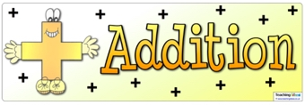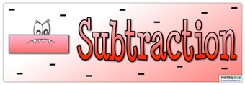
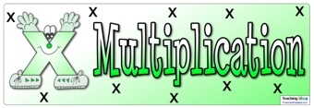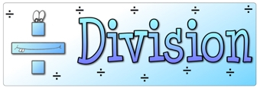
Author: Keeley Worrall
Date adopted by School Governors: 21st March 2022
Date to be reviewed: 20th March 2023
Policy Review cycle Annually
Version: 1

Signed: Chair of Governors -----------------------------------------------------Date-------------------------------------

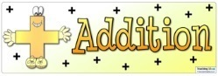 | Early Stages (EYFS)

Children will engage in a wide variety of songs and rhymes, games and activities. They will begin to relate addition to combining two groups of objects, first by counting all and then by counting on from the largest number.
They will find one more than a given number.
In practical activities and through discussion they will begin to use the vocabulary involved in addition.
‘You have five apples and I have three apples. How many apples altogether?’

Year One
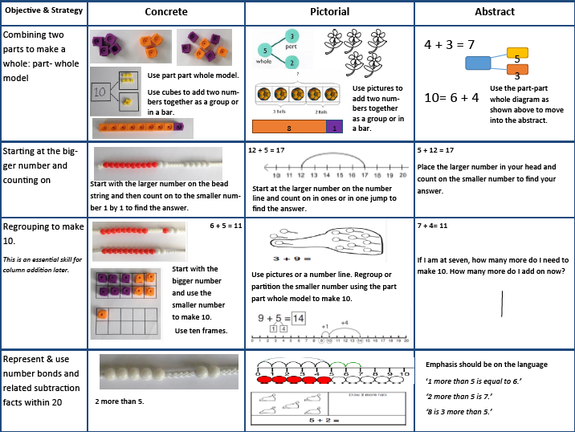

Year Two
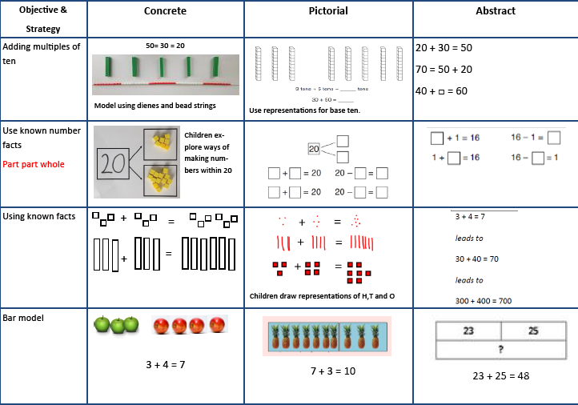

Year Two

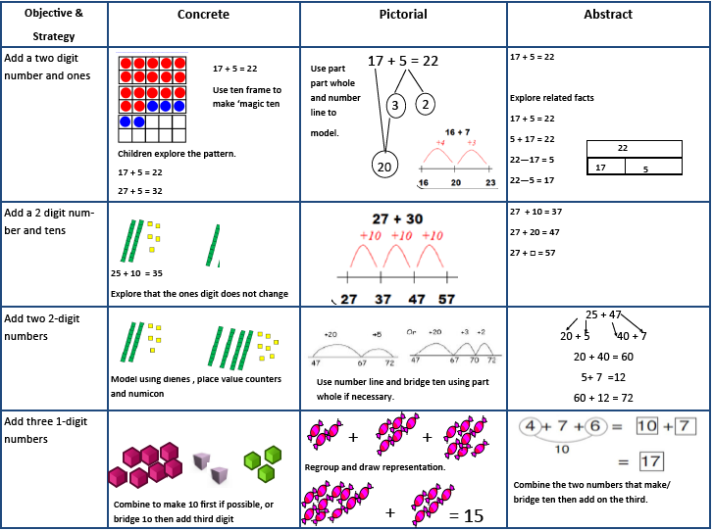

Year Three
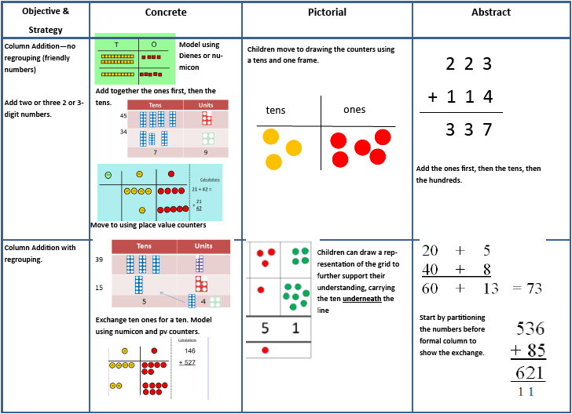

Years 4 - 6
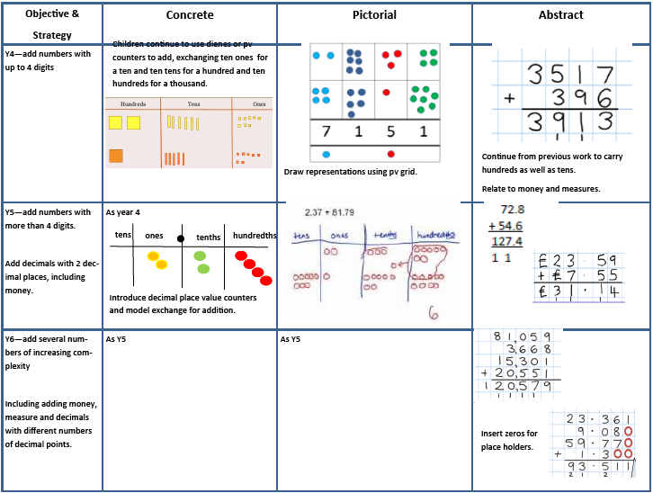

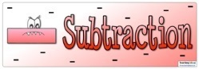 | Early Stages (EYFS)

Children will engage in a variety of counting songs and rhymes and practical activities.
In practical activities and through discussion they will begin to use the vocabulary associated with subtraction.
They will find one less than a given number.
They will begin to relate subtraction to ‘taking away’ using objects to count ‘how many are left’ after some have been taken away
‘Take two apples away. How many are left?’
Children will begin to count back from a given number.

Year One
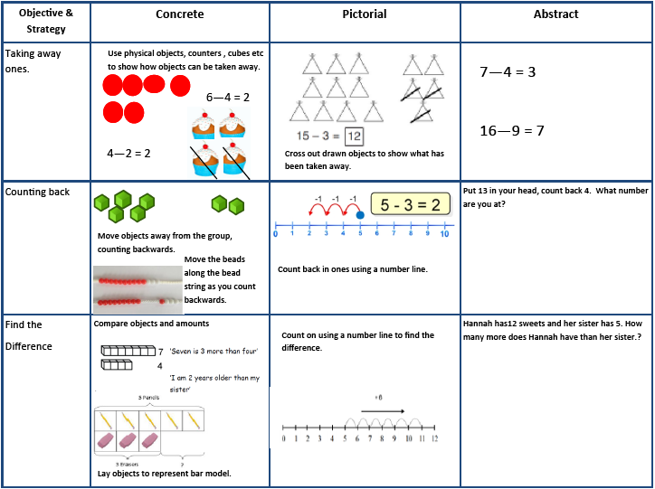

Year One
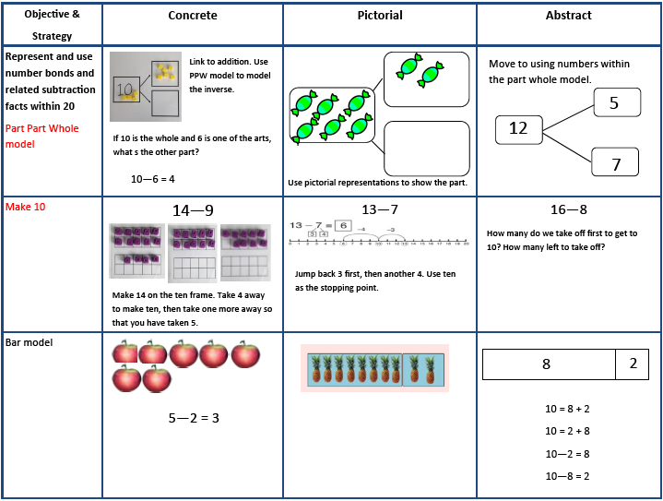

Year Two
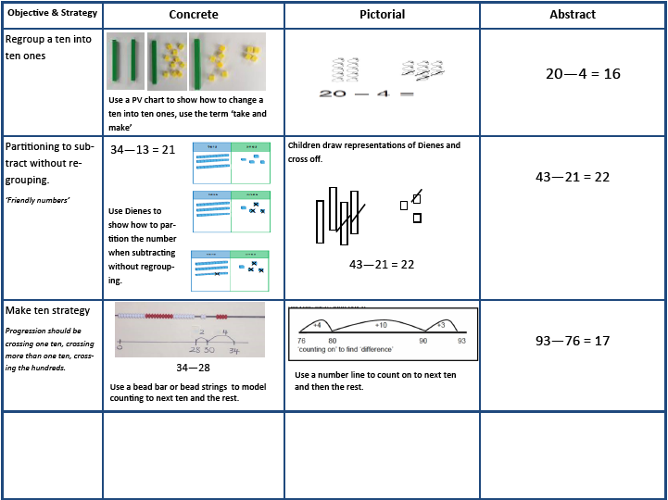

Year Three

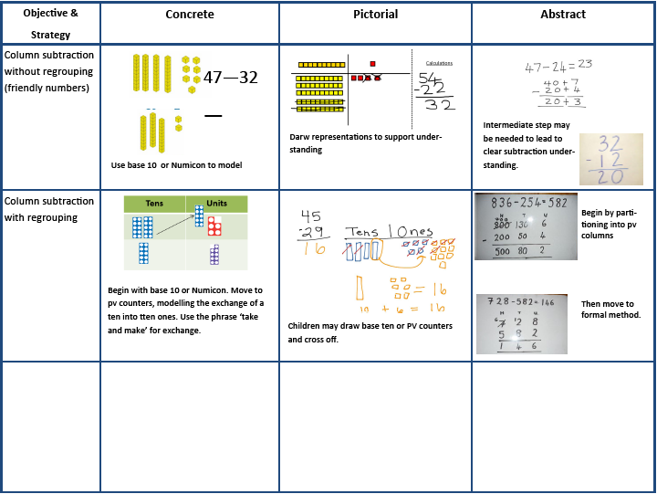

Year 4 - 6

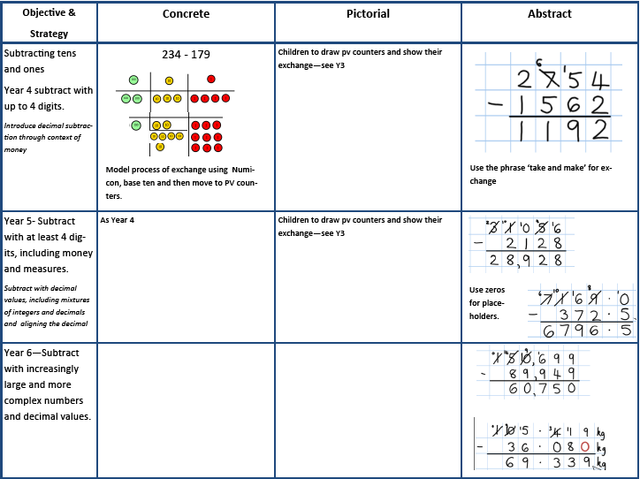

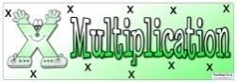 | Early Stages (EYFS)

Children will engage in a wide variety of songs and rhymes, games and activities. In practical activities and through discussion they will begin to solve problems involving doubling.
‘Three apples for you and three apples for me. How many apples altogether?’

Year One
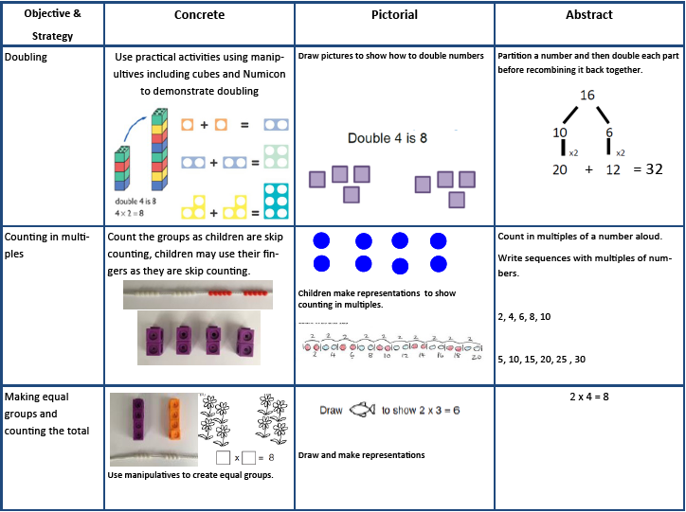

Year One

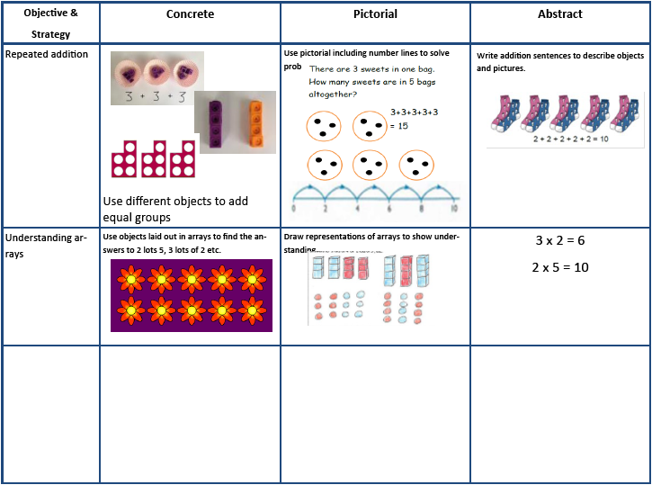

Year Two
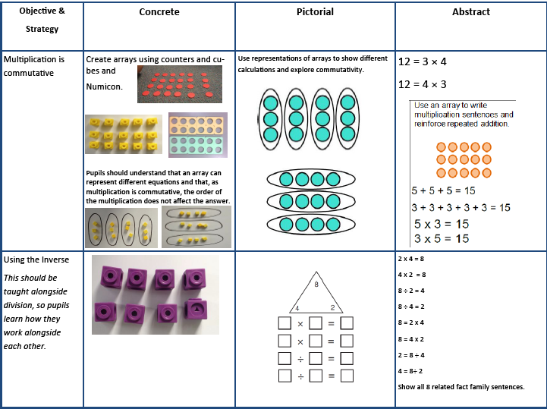

Year Three

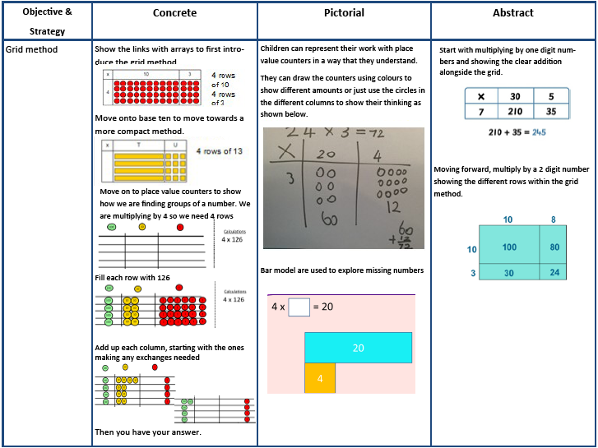

Year Four

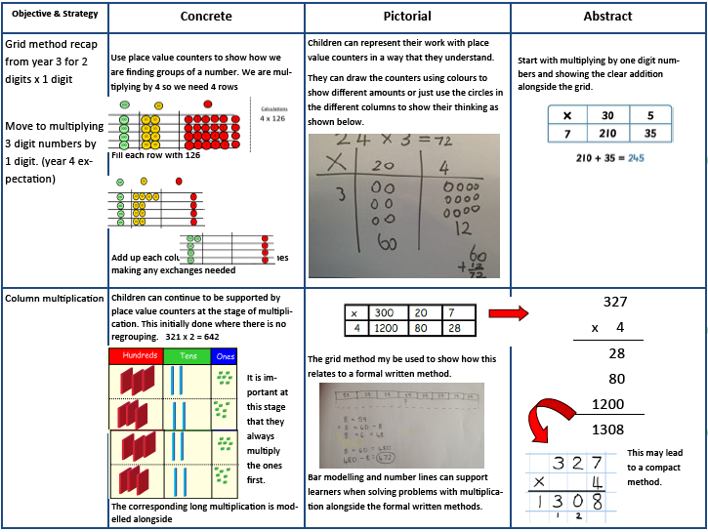

Year 5-6

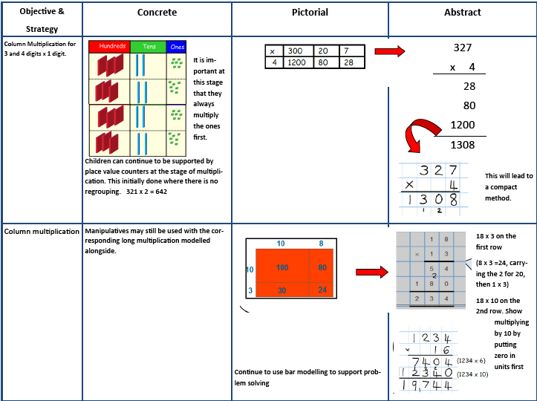

Year 6

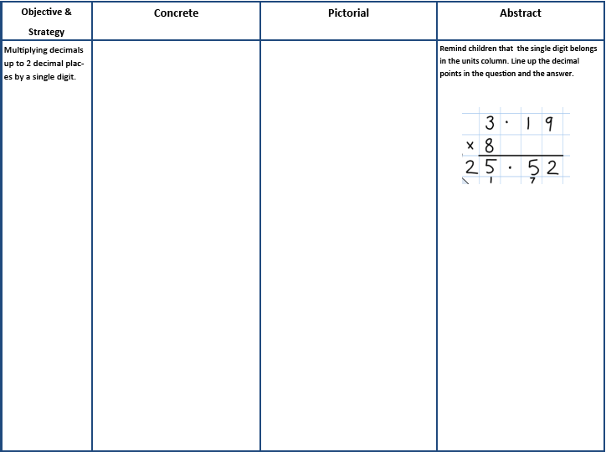

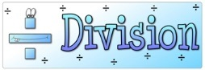 | Early Stages (EYFS)

Children will engage in a wide variety of songs and rhymes, games and activities.In practical activities and through discussion they will begin to solve problems involving halving and sharing.
Share the apples between two people.
‘Half of the apples for you and half of the apples for me.

Year One

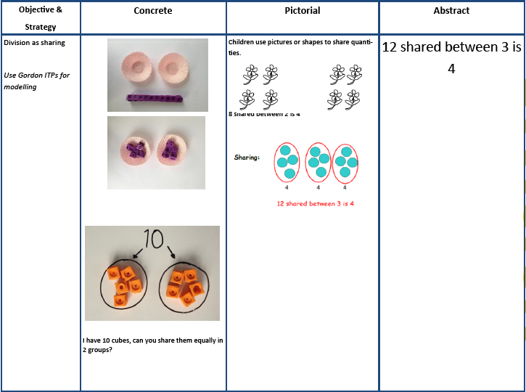

Year Two
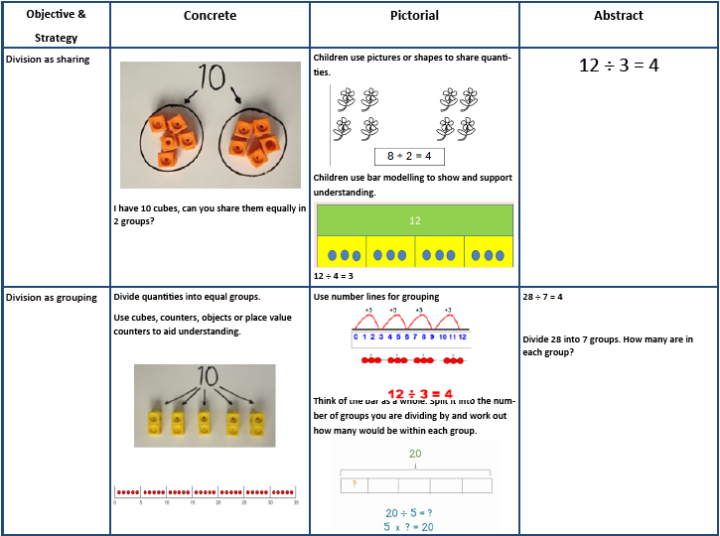

Year Three
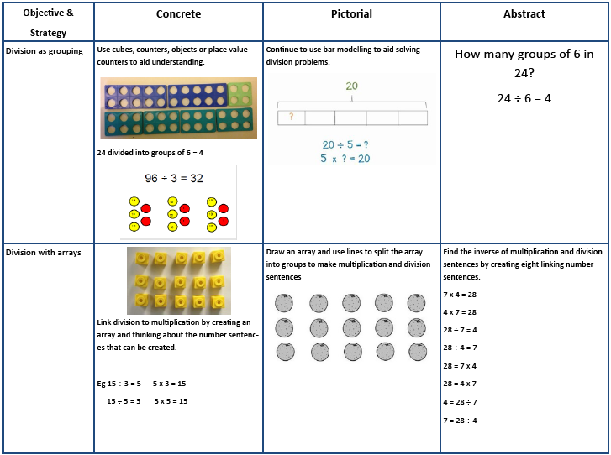

Year Three
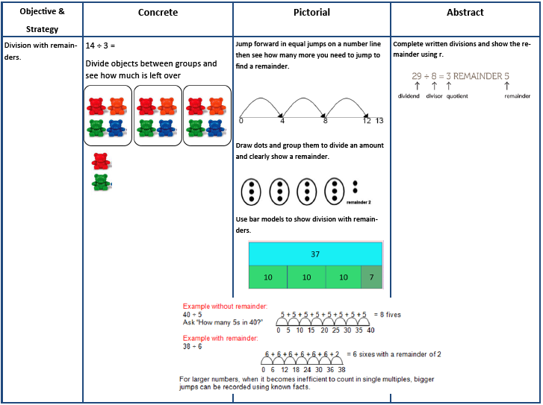

Years 4-6
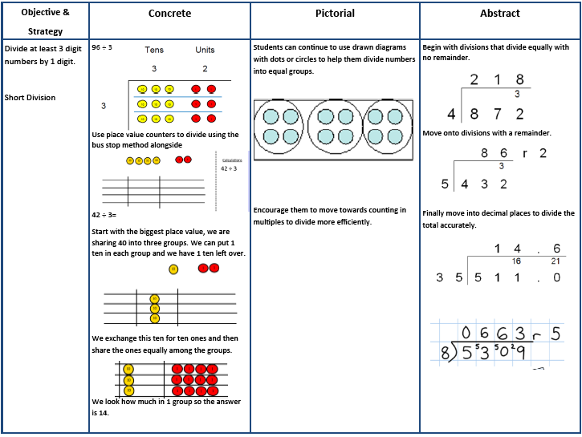

Year Six

- Divide numbers up to 4 digits by a two-digit number using the formal written method of short division where appropriate, interpreting remainders according to the context
- Divide numbers up to 4 digits by a two-digit whole number using the formal written method of long division, and interpret remainders as whole number remainders, fractions, or by rounding, as appropriate for the context
NB Ensure that children are confident with the methods outlined in the previous year’s guidance before moving on.

Continue to practise the formal method of short division as above.

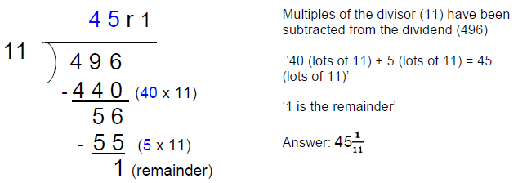
Dividing by a two-digit number using a formal method of long division:

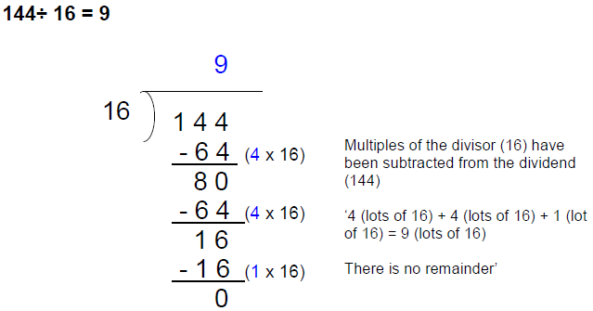
Standard short division does not help with the following calculation. However, it can be solved using long division (by repeated subtraction using multiples of the divisor):

Children will need to select the most effective method for each calculation/problem they meet, including whether to use the standard, formal written method of long division:
