The funding has been provided to ensure impact against the following **OBJECTIVE:**To achieve self-sustaining improvement in the quality of PE and sport in primary schools. It is important to emphasise that the focus of spending must lead to long lasting impact against the vision *(above)* that will live on well beyond the Primary PE and Sport Premium funding.   
  
**It is expected that schools will see an improvement against the following 5 key indicators:**

Sutton Manor Primary School- Evidencing the Impact of Primary PE and Sport Premium -

Vision for the Primary PE and Sport Premium

**ALL** pupils leaving primary school **physically literate** and with the **knowledge, skills and motivation** necessary to equip them for a **healthy, active lifestyle** and **lifelong participation** in physical activity and sport

1. the engagement of all pupils in regular physical activity – kick-starting healthy active lifestyles
2. the profile of PE and sport being raised across the school as a tool for whole school improvement
3. increased confidence, knowledge and skills of all staff in teaching PE and sport
4. broader experience of a range of sports and activities offered to all pupils
5. increased participation in competitive sport

Under the [Ofsted Schools Inspection Framework 2015](https://www.gov.uk/government/publications/school-inspection-handbook-from-september-2015), inspectors will assess how effectively leaders use the Primary PE and Sport Premium and measure its impact on outcomes for pupils, and how effectively [governors](https://www.gov.uk/government/publications/governance-handbook) hold them to account for this. Schools are required to [publish details](https://www.gov.uk/guidance/what-maintained-schools-must-publish-online#pe-and-sport-premium-for-primary-schools) of how they spend this funding and the effect it has had on pupils’ PE and sport participation and attainment.

**Developed by**  

­­­

Revised September 2016

Schools must include the following:

* how much PE and sport premium funding you receives for this academic year
* 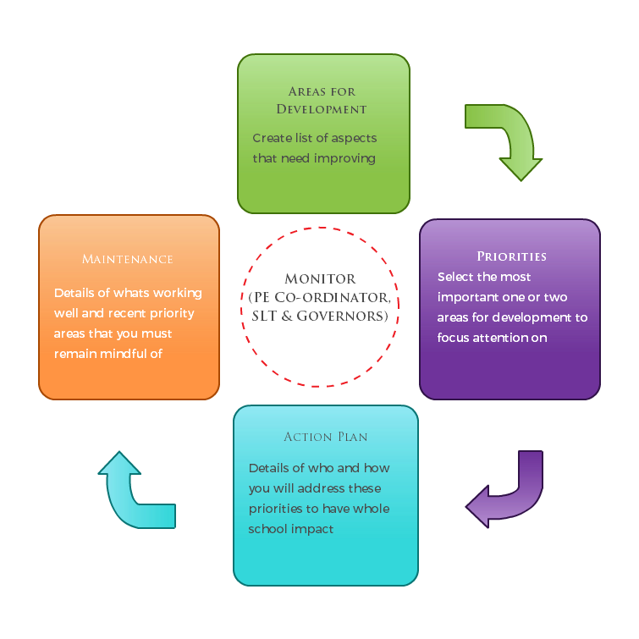a full breakdown of how you’ve spent or will spend the funding this year
* the effect of the premium on pupils’ PE and sport participation and attainment
* how you will make sure these improvements are sustainable

The published information should be clear and easily accessible and we recommend that you upload the following template (Annex 1) to your website for this purpose.

Improvements should enhance, rather than maintain existing provision. For example, where schools are using their funding to employ specialist coaches, these should be deployed alongside class teachers rather than displacing them, in order for their impact to be sustainable and to enable the upskilling of existing teachers.

Primary PE and Sport premium planning and actions should show how use of funding contributes to this vision through identified school priorities which can be measured through reference to key outcome indicators. It is important that the main drivers for improvement are those identified by the school through their self-review. Each school should aim to achieve the following objective:   
  
**OBJECTIVE:** To achieve **self-sustaining improvement** in the quality of PE and sport in primary schools. Please see Figure 1 (above): A process model to support your thinking.

**HOW TO USE THE PRIMARY PE AND SPORT PREMIUM**

Schools must use the funding to make additional and sustainable improvements to the quality of PE and sport they offer. This means that you should use the premium to:

* develop or add to the PE and sport activities that your school already offers
* make improvements now that will benefit pupils joining the school in future years

For example, you can use your funding to:

* hire qualified sports coaches to work with teachers
* provide existing staff with training or resources to help them teach PE and sport more effectively
* introduce new sports or activities and encourage more pupils to take up sport
* support and involve the least active children by running or extending school sports clubs, holiday clubs and [Change4Life](http://www.nhs.uk/change4life/Pages/change-for-life.aspx) clubs
* run sport competitions
* increase pupils’ participation in the [School Games](https://www.gov.uk/government/policies/getting-more-people-playing-sport/supporting-pages/the-school-games)
* run sports activities with other schools

You should **not** use your funding to:

* employ coaches or specialist teachers to cover [planning preparation and assessment (PPA)](https://www.gov.uk/government/uploads/system/uploads/attachment_data/file/341951/School_teachers__pay_and_conditions_2014.pdf) arrangements - these should come out of your core staffing budgets
* teach the minimum requirements of [the national curriculum](https://www.gov.uk/government/publications/national-curriculum-in-england-physical-education-programmes-of-study) – including those specified for swimming.   
    
  Guidance on the primary PE and sport premium can be found at [gov.uk](https://www.gov.uk/guidance/pe-and-sport-premium-for-primary-schools).  
  Annex 1 – Primary PE and Sport premium – Online reporting template

Name of school: Sutton Manor Primary School

**SECTION 1A – EVALUATION OF IMPACT/LEARNING TO DATE**

Academic: Click here to enter text.

In previous years, have you completed a self-review of PE, physical activity and school sport? Yes

Have you completed a PE, physical activity and sport action plan/ plan for the Primary PE and Sport Premium spend? Yes

Is PE, physical activity and sport, reflective of your school development plan? Yes

Are your PE and sport premium spend and priorities included on your school website? Yes

**SECTION 1B – SWIMMING AND WATER SAFETY self rescue focus.**

Swimming is an important skill and can encourage a healthy and active lifestyle. All Local Authority schools must provide swimming instruction either in key stage 1 or key stage 2. The [programme of study for PE](https://www.gov.uk/government/publications/national-curriculum-in-england-physical-education-programmes-of-study/national-curriculum-in-england-physical-education-programmes-of-study) sets out the expectation that pupils should be taught to:

* swim competently, confidently and proficiently over a distance of at least 25 metres
* use a range of strokes effectively [for example, front crawl, backstroke and breaststroke]
* perform safe self-rescue in different water-based situations.

|  |  |
| --- | --- |
| Swimming and Water Safety | Please fill out all of the below: |
| • What percentage of your Year 6 pupils could swim competently, confidently and proficiently over a distance of at least 25 metres when they left your primary school at the end of last academic year? | 54% |
| • What percentage of your Year 6 pupils could use a range of strokes effectively [for example, front crawl, backstroke and breaststroke] when they left your primary school at the end of last academic year? | 54 % |
| • What percentage of your Year 6 pupils could perform safe self-rescue in different water-based situations when they left your primary school at the end of last academic year? | 54% % |
| • Schools can choose to use the primary PE and sport premium to provide additional provision for swimming but this must be for activity over and above the national curriculum requirements. Have you used it in this way? | Yes |

This year, school swimming ceased in November due to the closure of the local pool facilities. Year 6 were able to have a 6 week allocation

**Vision**: **ALL** pupils leaving primary school **physically literate** and with the **knowledge, skills and motivation** necessary to equip them for a **healthy, active lifestyle** and **lifelong participation** in physical activity and sport.

**Objective**: To achieve **self-sustaining** improvement in the quality of PE and sport in primary schools against 5 key indicators:

1. the engagement of all pupils in regular physical activity – kick-starting healthy active lifestyles
2. the profile of PE and sport being raised across the school as a tool for whole school improvement
3. increased confidence, knowledge and skills of all staff in teaching PE and sport
4. broader experience of a range of sports and activities offered to all pupils
5. increased participation in competitive sport

2

**SECTION 2 – REFLECTION: WHAT HAVE WE ACHIEVED AND WHERE NEXT? 2020/** Choose a year

|  |  |  |
| --- | --- | --- |
| Key priorities to date: | Key achievements/What worked well: | Key Learning/What will change next year: |
| To upskill teachers in all year groups to ensure a higher standard of PE lessons.  To provide teachers with an improved PE curriculum, which is easy to follow and incorporates the 2014 curriculum. (Rising Stars Champions)  To provide more opportunities for pupils to take part in physical activity during lunchtime and/or after school.  To hire specialist sports coaches to help deliver enriched sporting opportunities and to support specific curriculum areas eg gymnastics  To attain School Games Awards Silver on to Gold  To participate in more school sports  tournaments  To inspire more children to take up physical activity, regardless of ability  To improve familial participation in sport, health and fitness programmes  . | School employs a sports coach, who has worked alongside teachers, improving their coaching skills. He also led the teaching of PE across the school.  Structure to the PE lessons has improved Teacher’s working knowledge is more secure. There is now improved progression in the teaching and learning of PE across the curriculum.  After school clubs that have been provided :   * A group of children have received Dance training from students at The Sutton Academy. * Beth Tweddle ,gymnastics for KS1 and KS2 * Cheerleading through Saints * Rugby training * Football for KS1 and KS2 * Children have had the opportunity Sky Try Rugby through Saints * David Campbell soccer * Couch to 2K   We have a **Forest School** to encourage that physical learning takes place outside of the classroom. Two members of staff have undertaken training. A group of children is selected to access Forest School every half term, for one afternoon. Every pupil in the school has accessed at least one forest school session.  All EYFS children have a weekly forest school session  Tournaments participated in this 2019 and 2020 year:  Handball,  Rounders  Football, girls and boys  Rugby  Netball  Dodgeball  EYFS football  Whittle Cup  Sutton Shield  Swimming gala  Cricket  Indoor athletics  Funding has paid for the coaches, new equipment, team kit and travel to and from sports tournaments.  Our school has the School Games Silver Award. To attain Gold we need to participate in ore competitive sports.  More sports equipment on the playground and school field  Work alongside the community development officer to run ‘Family fitness’ sessions once a week after school. | SPORTS COACH to work with all teachers in school to ensure that the ‘upskilling’ of teachers continues.  The Rising Stars Champions scheme of work offers a modern curriculum which is relatively simple to follow and impacts positively on the children.  A wider range of sports provided extra curricularly, cross country and athletics, look to bringing in additional professionals, Zumba, athletics and Sporthall  To provide additional athletics activities eg indoor sports hall activities, couch to 2K  (some restrictions due to Covid 19)  Continue with class daily challenge  Continue to use funding to bring in high quality experiences for children eg Beth Tweddle gymnastics, Saints Foundation rugby, Saints cheerleading, David Campbell soccer, dance through lessons and before/after school activities  Increase the competitive sports on offer such as netball, rugby, football  Continue to offer forest school to a group of different children every half term.  Early years have had weekly forest school sessions for at least two terms this academic year. This will continue from Autumn term 2019.  Forest schools will continue from Autumn 2020.  An additional member of staff is level 3 trained to deliver Forest schools, ensuring sustainability  Continue to offer this |

Use the space below to identify what your use of the Primary PE and Sport Premium has been to date, and priorities for the coming year:

**SECTION 3 – PLANNING YOUR PROVISION AND BUDGET FOR THE COMING YEAR   
Use the template below to plan how you intend on spending your Primary PE and Sport Premium funding this academic year, to include which of the 5 key indicators that priority relates to. The greyed out boxes allow you to re-visit this section later in the year to review and plan next steps.**

Step by step guidance notes to support completion of the template to achieve self-sustaining improvement in the quality of PE and sport in primary schools:

Step 1: Confirm the total fund allocated

Step 2: Review activities and impact to date either using the template you used last year or section 2 above

Step 3: Confirm your priorities in terms of impact on pupils and enter into column B to detail your school focus (e.g. improved the quality of children’s physical literacy at key stage 1)

Step 4: Cross reference these with the 5 key indicators for the Primary PE and Sport Premium by selecting the aspect(s) that this relates to (e.g. increased confidence, knowledge and skills of all staff in teaching PE and sport) and select these from the drop down menu in column A

Step 5: Complete column C to outline key actions to achieve these outcomes (e.g. whole staff training)

Step 6: Complete column D to detail funding allocated to this priority (e.g. £100.00)

Step 7: Complete column F to show how you plan to evidence the impact of this spend on young people

Step 8: Identify when you will revisit this template to update with actual spend, impact and sustainability next steps (greyed out columns E, G & H)

Step 9: The greyed out columns will be useful when reviewing your school’s spend later in the year to confirm actual spend and impact to support further plans for the future and sustainability.

|  |  |  |  |
| --- | --- | --- | --- |
| Academic Year: 2020-21 | | **Total fund allocated: £ 17,800** | |
| A | B | C | D | E | F | G | H |
| **PE and Sport Premium Key Outcome Indicator** | **School Focus/ planned Impact *on pupils*** | **Actions to Achieve** | **Planned Funding** | **Actual Funding** | **Evidence** | **Actual Impact (following Review) *on pupils*** | **Sustainability/**  **Next Steps** |
| **1. the engagement of all pupils in regular physical activity – kick-starting healthy active lifestyles** | Improve children's physical and mental health. | Ensure that two lesson of PE are timetabled each week. Promotion of physical and mental health during lessons.  The engagement of all pupils in regular physical activity – Chief Medical Officer guidelines recommend that primary school children undertake at least 30 minutes of physical activity a day in school |  |  | Pupil voice  Monitoring  Criteria checked throughout the year.  Data on participation levels monitored with key focus on none/low attendees.  PE subject leader file  Class evidence books |  | The school games mark remains the best and most quantifiable evidence of high quality PE within the school This must remain a priority and a focus throughout the following year (2020-21). |
| To provide a programme of swimming for years 2-6 |  | Purchase swimming SLA  with additional allocations for non -statutory ages |  | Transport £2500  Swimming SLA £5700 |  |  |  |
| Ensure a wider range of equipment is available to allow effective teaching and learning of PE and Sport and that teachers are confident in its use. | Review current PE stock / resources in order to support and offer good quality lessons.  Increase participation rates of children in PE lessons. | Audit current PE stock to establish what is needed to support high quality delivery.  Teachers to monitor children’s participation in lessons, letters send home where appropriate. | £1000 | £1000 | Stock orders.  Finance documents |  |  |
| **2. the profile of PE and sport being raised across the school as a tool for whole school improvement** | Review sports provision in school and ensure that there are links to other subjects  Tournaments | Link PE to science, PSHE and SEAL topics.  Entrance Fees  Complete Pupil Voice to establish children’s confidence, self-belief and enjoyment.  Children will learn the importance of sports -personship, teamwork and working together to achieve a given goal. |  |  | Examples of ‘cross-curricular’ lesson planning.  Photographic  evidence from enrichment weeks.  Pupil voice carried out and analysis completed. |  |  |
| **3. increased confidence, knowledge and skills of all staff in teaching PE and sport** | Improve quality of curriculum planning to ensure staff deliver effective lessons  Sports coach to work alongside current teachers to improve their skills and knowledge and therefore deliver confident, higher quality | Review the new scheme of work.  Co-ordinator lesson observations to ensure planned curriculum is being delivered and impacts on children’s engagement.  Sports coach to support staff in the planning and delivery of PE lessons. Increasing pupil engagement. | Payment for sports coach  £14000  Gymnastics £1100 | £14,000 | Funding required to release PE lead to attend network meetings to discuss and implement effective strategies to promote healthy lifestyles   |  | | --- | | Formal/in-formal lesson observation notes.  Children’s engagement survey results. |   Coaches in place, activities being delivered. Staff comments, lesson observations and planning. |  |  |
| **4. broader experience of a range of sports and activities offered to all pupils** | Review extra-curricular provision, aiming to increase participation levels and target year groups with limited access to clubs. | Broaden the extra-curricular clubs available to children across KS1 & 2.  Carry out Pupil Voice to see what pupils would like to have as clubs. | Gymnastics after school (part of the £1,100)  Soccer coaching £512 | Transport to tournaments-  £480 | Greater number of extra-curricular clubs, increase in pupil numbers – analysis report.  Pupil Voice survey results. |  |  |
| 5. **increased participation in competitive sport** | Increase competition participation – raise profile of school and the moral of children.  Purchase Shapes SLA | Participate in more competitions across the LA – receive regular updates from School Games.  Arrange suitable staff cover to attend events.  Arrange suitable transport to attend events.  Arrange internal sports competitions  Transport |  | As above  Shapes SLA £1100 | Record of the number and type of events.  List of internal events that have taken place. |  |  |
| 1. **Make links with good mental health and wellbeing programme** | More sports participation for all children | Sign up for competitions, twice weekly PE sessions  Forest school approach |  |  |  |  |  |
| 1. **To continue to run forest schools across the school** |  |  |  | £920 training  £500 resources |  |  | An additional member of staff to be level 3 forest school trained |

­­­­  
Completed by (name and school position): Mr I Bonney (DHT) Mrs M Gladman (HT) , Miss H Lewis (Sports subject leader, teacher)

Date: 15/09/2020

After every update, please remember to upload the latest version to your website.

Review Date: 01/04/2021

**Developed by**  

**Supported by**