Local Offer 2021-22

MISSION STATEMENT

SUTTON MANOR SCHOOL –A PLACE WHERE CHILDREN SHINE.

Headteacher: Mrs Monica Gladman
Deputy Headteacher: Ian Bonney

SEND Team
SENCo: Mrs Julie Moran
SENCo Support: Miss Lisa Dykes
Learning Mentor: Mrs Kelly Parr

Special Needs Governor: Mrs Lynsey Adamson

Our Vision for Sutton Manor Community Primary School

Sutton Manor School is a Maintained Mainstream Community Primary School ‘where children shine’ and all who are involved with the school, work very hard to ensure our children have many and varied opportunities to do so. School is at the heart of the community we serve.

Our shared vision is that;

- We provide a happy, nurturing environment, which is welcoming, attractive and safe, ensuring the needs of all children are met.

- The creative curriculum we offer is balanced, broad, fun and enjoyable for all and will enable each child to reach their full potential, regardless of their ability.

- We are dedicated to ensuring high levels of attainment and achievement. We aim to raise awareness of the possibilities of future careers, which will raise children’s and parents’ aspirations.

- We will extend learning opportunities beyond the classroom and the curriculum, to meet the needs of our children and community.

- We will enrich the lives of all who access our provision and support and enhance opportunities for economic well-being, be they members of our school community or of the wider community.

- We will work in partnership with other agencies to promote awareness of a Healthy life style for children, families and our local community.

- We pledge to respect the human rights of our pupils, staff and other members of our community, ensuring equality for all.

SCHOOL AIMS

The school will develop lively, enquiring minds by: -

- Fostering the individual potential of each child

- Ensuring equal access to a broad and balanced curriculum

- Providing a framework for all children to feel valued and gain confidence

- Encouraging all children to take responsibility for their own learning

The school will create and foster an atmosphere that is conducive to learning by:

- Encouraging a caring and thoughtful attitude to others

- Continuing to encourage the moral, social, cultural and spiritual development of all the children

- Providing a welcoming and secure environment in which all children parents staff governors and the wider communities have an opportunity to prosper and work

What is the local offer?

Our local offer is information for parents/carers of children who have Special Educational Needs (SEN) or a disability, and all of those who support children with additional needs. The information outlines the support and provision they can expect to receive whilst attending this school and how we can support all elements of their Education. It is intended to answer questions that may be asked by parents of children with SEND who attend our school.

See SEND Policy- available on school website.

Here are some answers to questions that parents/carers might have about Sutton Manor Primary School’s Local Offer

Abbreviations | Meaning
Targeted Support | Children who are receiving intervention to support their meaning
SEN Support | Children who are receiving specific intense learning support programmes and intervention to support them with their learning needs. these children are often known to external agencies for support and assessment
Enhanced Support | Children who have ‘top up’ funding to supplement the support they already receive in school
EHCP | Education Health care Plan
ASD/ASC | Autistic Spectrum Disorder/Autistic Spectrum Condition
CAMHS | Child and Adolescent Mental Health Service
EP | Educational Psychologist
SEND | Special Educational Needs and Disabilities
SEND Code of Practice | The legal document which sets out the requirements for educating children with special educational needs.
C & L | Cognition and learning difficulty
C & I | Communication and interaction difficulty
VI | Visually impaired
HI | Hearing impaired
S & P | Sensory and Physical difficulty
SEMH | Social, Emotional and Mental Health
SEBD | Social, Emotional and Behavioural Difficulties
SENDCo/SENCo | Special Educational Needs and Disabilities Co-ordinator/ Special Educational Needs Co-ordinator
LSA | Learning Support Assistant

- How are Special Educational Needs defined?
A child or young person has SEN if they have a learning difficulty or disability which calls for special educational provision to be made for them. A child of compulsory school age or a young person has a learning difficulty or disability if they:
(a) Have a significantly greater difficulty in learning than the majority of others of the same age; or
(b) Have a disability which prevents or hinders them from making use of educational facilities of a kind generally provided for others of the same age in mainstream schools or mainstream post-16 institutions.
A child under compulsory school age has special educational needs if they fall within the definition at (a) or (b) above or would so do if special educational provision was not made for them.
If your child has a need that requires something additional or different from an ordinary differentiated
curriculum then we will place them on our SEND register. At Sutton Manor we follow a graduated approach to supporting children presenting with SEND.

- How will the school know if my child needs extra help?

A proactive and graduated approach is adopted by the school in anticipating the difficulties some children may encounter in particular areas of learning. Information is gathered about pupils through Pupil Progress Meetings, SEND Pupil Progress Meetings, End of Year Reports, Mid-term Assessment, previous schools (where appropriate) and discussions with staff. Appropriate and differentiated learning tasks will be planned for to support children’s progress. School identifies children with SEND through procedures outlined in our SEND Policy [a copy of which is available on request].

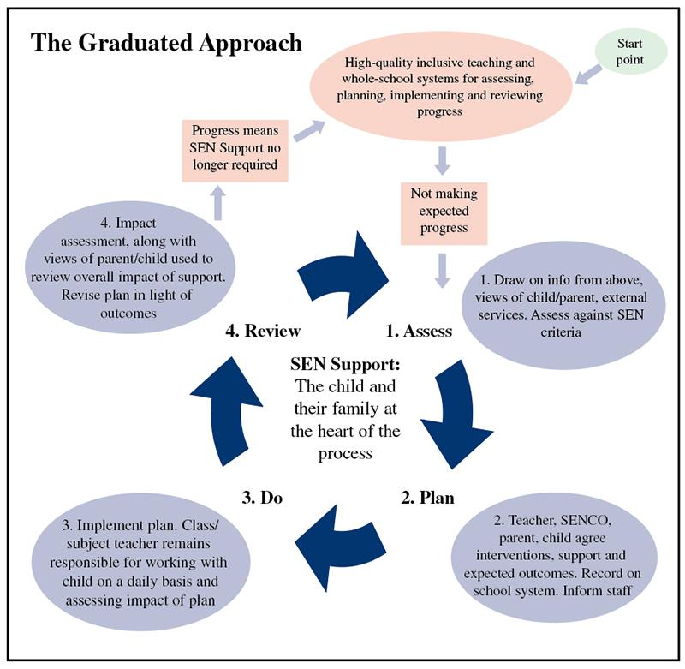

- Who is the best person to talk to about my child’s difficulties with learning / SEND?

School has a designated SEND Team –SENCo & SENCo Support, who will coordinate provision for pupils with SEND. School has a highly skilled team of Teachers and Teaching Assistants (TA) to support all children within school in accessing the curriculum.

- How will I know how the school will support my child?

Parents are informed regularly through:

- Individual Education/Behaviour Plans and Review half termly
- Pupil Progress Meetings
- Home School Books
- Open door policy in place.
- Parent friendly assessment criteria.
- Training events signposted for parents to attend if they so wish.
- Parents Evenings throughout the academic year
- Enhanced funding reviews and EHCP reviews.

- How will the curriculum be matched to my child’s needs?

All children within school will follow the National Curriculum. If some children are likely to encounter areas of difficulty, planning and tasks set will reflect differentiation to meet their needs.
- How will I know how my child is doing?
Parents are informed regularly through:

- Individual Education /Behaviour Plans and Review
- Pupil Progress Meetings
- Home School Books
- Parent friendly assessment criteria.
- Informal drop in sessions – we have an open door policy at Sutton Manor and parents/carers are welcome to come into school and discuss their child, with the SEND Team if they have any concerns.
- Parents evenings
- If teachers have concerns they will work closely with the school SEND Team. Parents will be informed and listened to regarding concerns.
- The SEND Team will inform parents if referrals to external agencies are required to support your child’s learning.
- If your child has a Provision Agreement or an Education, Health and Social Care Plan, then you will be invited to an annual review to discuss progress.

- How will the school help me to support my child’s learning?

Advice and support will be provided by the Teacher and the SEND Team. When needed School will support parents with their child’s learning by brokering links with external support services. All children are supported socially and pastorally by staff, who know the children well. We have a high ratio of staff to children, with at least one teacher and Learning Support Assistant in each class. Parents are encouraged to take an active role in their child’s learning. You will be involved in parent evenings and appropriate reviews. We have an open-door policy and if you would like any specific advice on how to support your child at home, we will be more than happy to set up additional meetings.

- What support will be available for my child’s overall well-being?

- Staff within school are helpful, friendly and supportive.
- Designated Safeguarding Lead
- School has a designated Learning Mentor.
- Whole School Behaviour Policy is in place.
- All Teaching Assistants are First Aid trained.
- Staff have regular training through the Health Service with regard to: allergies, asthma, epilepsy and diabetes.
- A medicine policy is in place and followed accordingly.
- A proactive involvement from EWO to promote good attendance.
- See School policy for Safety and Well Being.

- What happens if my child has a high level of need?

If a child has a high level of need a multi-agency approach will be adopted to assess and determine how and where needs are best met. Advice will be sought from specialist services for example:
- Health
- Speech and Language
- Physiotherapy
- LASc
- Educational Psychologist.
- Local Authority Inclusion Officer
- Learning Support Service
- CAMHs
- Community Paediatricians
- The Children’s Disability Team
- Social Care
- Behaviour Improvement Team
- Counselling Teams
- Pupil Referral Units (PRUs)
- Specialist Schools such as Lansbury Bridge.
- St Helens IASS - Information, Advice and Support Service

Following the recommendation set by the aforementioned professional’s decisions will be made on how best to meet any specific needs. If your child has a high level of need then we will work closely with St Helens Local Authority to ensure the package is in place that allows us to meet the needs of your child. This is usually done through a Provision Agreement or Education, Health and Social Care Plan (EHCP). Your child’s needs will be assessed and a support plan involving all agencies involved will be put in place.

- What specialist services and expertise are available at this school?

- To ensure that we support children to make progress with their learning, school staff, regularly update their knowledge and have good links with external specialists, should we require their services.
- School has direct access to a wide range of services all of which can support both parents/carers and children – as indicated above in point 9.

- Are the staff who support children with SEND in this school,
provided with appropriate training?

- All staff in school access training appropriate to their needs and that of the school as part of Continuing Professional Development (CPD). Staff are trained regularly in key areas of the curriculum and also in identifying and supporting children with specific difficulties around learning, child development and social and emotional problems children may experience.
- Training has been delivered in the areas of Diabetes, autism, speech, language and communication, Trauma and Adverse Childhood Experiences, Team Teach, ADHD support and specific phonics training.

- Mental Health and Well-being training/ support programmes and service links through the Health Hub Cluster Meetings.

- There is a Continuing Professional Development Officer who ensures that staff are aware of training available to meet their needs. Where necessary, specialist training is brought into the school.

- Individual staff are trained in First Aid and are strategically placed around school.

- The SENCO attends L.A. training and attends key regional training’ which is then shared with all staff.

- All staff are Team-Teach trained which provides staff with ‘a framework to equip individuals with attitudes, skills and knowledge to facilitate environments that are free from fear and safe from harm.’

- The SEND Team provides in-house training on developing IEPs/IBPs and around specific requests from staff, or as necessary to support a particular child or group of children.

- How will my child be included in activities outside of the classroom,
including school trips?

Risk assessments are carried out for activities outside of the classroom and for school trips. All children are included in trips and they participate fully in all school activities where possible. School gives due consideration to the Disability Discrimination Act when planning activities. We always try to ensure that school activities and trips are fully accessible for every student. We regularly use disabled access transport and we choose activities that ensure everyone is included. On the rare occasion that something has to be organised that we feel is unsuitable for a child with a specific Special Educational Need, we will always discuss this with the parent to try to resolve any concerns or consider possible alternatives. All reasonable adjustments will be made to meet the specific needs of your child.

- How accessible is the school environment?

The school environment is fully accessible and is in line with all disability access requirements. We have a fully accessible disabled bathroom that includes shower and adjustable bed. We take any sensory support advice on board regarding issues for students with visual or hearing impairments or anything that can support the learning environment. Any resources that are required to meet the needs of SEND pupils are secured through the SEND budget. These have included ICT Support, programmes and specific resources such as tangle toys, wobble cushions and pencil grips.

- How will this school prepare and support my child when there are starting, leaving this school or moving to another year?

- New children joining the school have a pre-visit meeting. Information is received from the child’s previous setting and used to inform the level of support needed.

- Transition meetings are planned for when a child is moving into another year or school. This can involve the child, parents, current staff and new adults involved.

- Visits to new school settings can be arranged.

- When moving classes in school information will be passed on to the new class teacher in advance. Your child will have transition visits to meet the class teacher and become familiar with their new classroom.

- School uses the CPOMs system of record keeping this ensures a full transfer of information/documentation between schools.

- What if my child needs transport to and from school?

This resource is not available in our setting.

- How are the school’s resources allocated and matched to the children’s special educational needs?

School SEND budget is allocated through the Local Authority. Any allocation of support in school is based on an analysis of need. Contributors to the decision making process may include Governors, Staff, Parents, Educational Psychologist or the Local Authority inclusion officer. School have a Team around the child approach to support –enabling the child’s needs to be met and independence skills to be developed. This prevents attachment to one particular member of staff providing a holistic approach.

- How is the decision made about how much support my child will receive?

Decisions are initially made through the school staff, SEND Team, Head teacher and Local Authority. Further decisions are made through planning and consultation, when an external specialist assessment maybe carried out. Parents are consulted throughout all stages of this process. Impact is measured through continuous assessment, monitoring and planning. If your child’s needs can’t be met through school-based funding and provision, we will apply to the local authority, either for Enhanced / E.H.C.P funding or request E.H.C.P assessment if we agree that the placement is not appropriate. You will be contacted and invited to attend any appropriate meetings.

Educational Health Care Plans
(EHCPs) Educational Health Care Plans are allocated by the Local Authority when the level of need is high. EHCPs indicate personal goals and will describe the support your child will receive while they are in education or training. Personal budgets are available to give parents more control over the support parents and their child receive. The amount given, and how it can be spent, is something that would be agreed with the local council.

SEND support
SEND support is provided within school for children with additional needs covering the four areas of need which are:
- Communication and interaction.
- Cognition and learning.
- Social, emotional and mental health.
- Sensory and/or physical.
- All children are provided with 'Quality First Teaching'.
- Children with special educational needs have Individual Support Plans/Individual Education Plans put in place, outlining targets and strategies to support your child. IEP’s are reviewed every half term with the child and shared with parents.
- The school SEND Team meets regularly with the Educational Psychologist, LASc, the Behaviour Support Team, and the local authority inclusion officer and any child needing support will be identified to the relevant professionals and given any support necessary.
- If a child requires Speech and Language support, school, with the permission of the parents, will put in a referral.
- Children identified as needing extra support will have interventions timetabled.
- Some children may require further support and interventions delivered by outside agencies such as the Behaviour Improvement Team, speech and language or LASc.

- How will I be involved in discussions about and planning for my
child’s education?

School values parental involvement and welcomes your input into the process of IEPs, pupil progress meetings and contributions to assessment. Children’s progress is shared throughout the school year during parents evening and informal drop in meetings. Annual reports are written for parents/carers at the end of the academic year. As parents you are encouraged to be involved in all aspects of your child’s school life. You will be informed of any additional provision and kept up to date with progress. Any concerns will be brought to your attention at the earliest opportunity and you will be welcomed into school for all relevant meetings. If you are unsure about anything to do with your child’s provision then you should contact school directly so we can work together to resolve any issues and ensure that everything is clear and understood and the correct decisions are made.

- Who can I contact for further information?

Headteacher – Mrs Monica Gladman
SENCo - Mrs Julie Moran
SENCo Support – Miss Lisa Dykes
Telephone Number: 01744 678700

Local Authority Inclusion Officer at Atlas House

Local Authority Local Offer – St Helens Education Website.

Abbreviations
AAP | Attendance Advisory Practitioner
ADD | Attention Deficit Disorder
ADHD | Attention Deficit & Hyperactivity Disorder
ASD | Autistic Spectrum Disorder
BESD | Behavioural Emotional & Social Difficulties
CAF | Common Assessment Framework
CAMHS | Child & Adolescent Mental Health Service
COP | Code of Practice
CP | Child Protection
DCD | Developmental Co-ordination Disorder
EAL | English as an Additional Language
EP | Educational Psychologist
FSM | Free School Meals
HI | Hearing Impairment
IEP | Individual Education Plan
ISR | In School Review
KS | Key Stage
LAC | Looked After Children
LEA | Local Education Authority
MAM | Multi Agency Meeting
MLD | Moderate Learning Difficulty
NC | National Curriculum
OT | Occupational Therapist
PSP | Pastoral Support Programme
Salt | Speech and Language Therapy
SEN | Special Educational Needs
SEND | Special Educational Needs & Disability
SENco | Special Educational Needs Co-ordinator
SpLD | Specific Learning Difficulty
VI | Visual Impairment

